A Structured Approach to Data Cleaning, Imputation, and Dimensionality Reduction for Traﬃc Crash Frequency & Severity Analysis
Author: Muneeb Shehzad Butt
Aﬃliation: University of Central Punjab
Corresponding Author Email: L1S23phdc0003@ucp.edu.pk

Abstract
Understanding how often traffic crashes occur is vital for shaping effective, preventive road safety strategies. This research presents a well-defined analytical framework designed to assess road crash frequency, drawing on a robust dataset of over 367,000 reported incidents across Queensland, Australia, from 2001 through 2020. The study begins with comprehensive data preparation, including detailed cleaning and imputation to correct for spatial omissions, inconsistencies, and categorical anomalies—ensuring that both geographic and statistical accuracy are upheld.
Temporal trends reveal distinct peaks during weekday commuting hours, specifically 7–9 AM and 4–6 PM, with an additional rise late Friday and Saturday nights between 8 PM and 2 AM. These nighttime surges are often associated with fatigue and alcohol-impaired driving. Monthly variations show elevated crash volumes in April, August, and December—months typically linked to increased travel and seasonal movement. Spatially, crashes are most densely concentrated in urban hubs like Brisbane and the Gold Coast, whereas rural regions, while reporting fewer incidents overall, tend to experience more severe outcomes. The high resolution of GPS data enhances the precision of regional segmentation and hotspot detection.
In terms of vehicle involvement, passenger cars dominate crash statistics, trailed by motorcycles and bicycles. Pedestrian incidents are especially prevalent during evening hours in city environments. This approach—centered on crash frequency rather than severity—shines a light on repeated risk exposure and recurring hazardous scenarios. By offering a repeatable method and a comprehensive dataset, the study equips transport officials, planners, and decision-makers with actionable insights to enforce targeted safety measures, optimize resource deployment during critical periods, and foster the creation of safer, more resilient transportation systems.

Introduction
Traffic crash frequency—the rate at which crashes occur within defined temporal or spatial boundaries—serves as a cornerstone in forward-thinking road safety initiatives. Unlike crash severity modeling, which concentrates on the outcomes of individual events, frequency analysis addresses exposure risk: identifying when and where crashes are statistically more likely. This knowledge empowers transportation agencies to implement proactive safety interventions, refine infrastructure, and allocate enforcement efforts more strategically based on time- and location-dependent patterns (Lord & Mannering, 2010; El-Basyouny & Sayed, 2006; Montella, 2010).

Traditionally, researchers have employed statistical models such as Poisson and Negative Binomial regressions—along with spatial and zero-inflated extensions—to examine crash frequency (Washington et al., 2010; Lord & Miranda-Moreno, 2008; Aguero-Valverde & Jovanis, 2006). Although these approaches offer statistical robustness, they frequently operate on the assumption that datasets are already clean, consistent, and complete. In practice, datasets sourced from field records or government platforms often fall short: plagued by absent GPS data, vague or inconsistent vehicle identifiers, formatting anomalies in timestamp fields, and categorical fragmentation. These deficiencies not only compromise model performance but can also misrepresent true hotspot zones and obscure recurring risk cycles.
Moreover, research to date has leaned heavily toward crash severity prediction, with frequency modeling often relegated to secondary or descriptive roles. Machine learning and statistical literature alike have focused on injury outcome prediction using methods such as decision trees (Abdel-Aty & Haleem, 2011), latent class analysis (Liu & Chen, 2009), and hierarchical classification schemes (Ding & Simonoff, 2010), while giving limited attention to the foundational work required for robust frequency analysis. Even recent studies leveraging advanced algorithms frequently overlook the preprocessing complexities inherent in real-world crash data (Ma et al., 2015; Zhang et al., 2020).
This study responds to these limitations by proposing a systematic and transferable crash frequency analysis pipeline, grounded in a rich dataset of over 367,000 crash reports from Queensland, Australia (2001–2020). The core contributions are as follows:
- A rigorous preprocessing protocol integrating spatial recovery through reverse geocoding, statistical imputation, and normalization of temporal and categorical attributes—restoring over 150,000 incomplete location entries and ensuring data fidelity.
- The development of temporal indicator variables and composite features capturing behavioral and environmental rhythms—such as peak commuting hours and weekend nightlife exposure—essential for identifying frequency trends.
- Implementation of Principal Component Analysis (PCA) to reduce dimensionality in complex temporal-environmental interactions while preserving interpretability and computational efficiency.
- A scalable, jurisdiction-agnostic framework designed to detect temporal-spatial crash patterns, inform policy prioritization, and guide data-driven infrastructure planning.

In contrast to prior work that often treats preprocessing as a secondary concern, this research positions it as a central pillar of meaningful crash frequency modeling. The proposed pipeline enables richer exploratory insights and greater predictive reliability, offering a robust, adaptable foundation for traffic safety analysis, regional planning, and smart mobility initiatives (Chien et al., 2002; Quddus, 2008; Khan et al., 2020).

Dataset Overview
This study utilizes a robust, longitudinal dataset comprising 367,230 reported traffic crash cases from Queensland, Australia, covering the period from January 2001 to December 2020. Sourced from the Queensland Government Open Data Portal, the dataset includes officially recorded crash statistics derived from police reports and administrative monitoring systems. It encompasses a wide array of crash events across urban, peri-urban, regional, and remote environments, ensuring a representative geographic spread.
Importantly, the dataset captures a comprehensive range of variables, blending system-level conditions—such as road surface type, lighting, and crash location—with detailed event-specific attributes like time of occurrence, crash type, and vehicle involvement. This level of detail makes it well-suited for in-depth, layered frequency analysis. Owing to its scale, richness, and 20-year temporal scope, the dataset has been cited in multiple transportation and data mining studies (Ma et al., 2015; Khan et al., 2020).
2.1 Dataset Composition and Structure
The dataset contains more than 50 variables, each corresponding to a recorded attribute of an individual traffic crash. These variables are categorized into several primary domains

Category | Representative Variables
Temporal Variables | Crash_Year, Crash_Month, Crash_Day_Of_Week, Crash_Hour, Crash_Time, Crash_Date
Spatial Variables | Crash_Latitude, Crash_Longitude, Police_Region, State_Road_Name, Crash_Postcode
Environmental Data | Crash_Lighting_Condition, Road_Surface_Condition, Weather_Condition, Speed_Zone
Crash Mechanics | Crash_Nature, Crash_Type, Crash_DCA_Code, Crash_Direction, Intersection_Control
Vehicle Involvement | Count_Unit_Car, Count_Unit_Truck, Count_Unit_Motorcycle_Moped, Pedestrian_Involved
Administrative | Crash_ID, Crash_Severity, Crash_Report_Type, Crash_Traffic_Control_Type

Although Crash_Severity is present, this study does not treat it as the modeling target. It is only used descriptively to enrich context in frequency-driven clusters and exposure hotspots.
The dataset is robust in that it captures both high-volume metropolitan corridors (e.g., Brisbane CBD) and low-density regional roadways, enabling comparison across diverse roadway settings. The combination of GPS coordinates, police region tags, and timestamped data supports both spatial mapping and time-series crash distribution modeling.
2.2 Data Quality Challenges and Missingness
As with most field-collected administrative datasets, quality issues are prevalent and must be addressed systematically (Rubin, 1976; Little & Rubin, 2019). Missingness was found to be non-random and disproportionately high in spatial and temporal fields, especially in crashes reported from rural or remote regions.
Spatial Fields:
- Crash_Street_Intersecting missing in 56.6% of cases
- State_Road_Name missing in 53.8%
- Crash_Postcode partially missing or inconsistent in outer districts
Temporal Fields:
- Crash_Hour missing or invalid in ~12,000 records
- Crash_Date and Crash_Time inconsistently formatted across collection years
Categorical Noise:
- High cardinality and label inconsistency in Lighting_Condition and Crash_Nature
- Multiple semantically identical categories (e.g., “Night”, “Night Time”, “Darkness with No Light”) treated as separate classes before cleaning

Column | Missing Values | % Missing
Crash_Street_Intersecting | 207,966 | 56.63%
State_Road_Name | 197,558 | 53.80%
Crash_Hour | 12,306 | 3.35%
Crash_DCA_Description | 84 | 0.02%

These data quality issues pose significant challenges for frequency analysis, where the volume and timing of crash events are central metrics. Missing timestamps or unmappable location references can compromise the integrity of any model attempting to detect regional or temporal crash trends (Aguero-Valverde & Jovanis, 2006; Quddus, 2008).
2.3 Preprocessing and Validation Protocol
To address these structural inconsistencies, a detailed preprocessing pipeline was implemented, comprising four key phases:
Step 1: Geolocation Recovery via Reverse Geocoding
Using OpenStreetMap’s Nominatim API, over 150,000 records were enriched with recovered road names based on their GPS coordinates. This technique proved especially reliable in urban and suburban areas, where spatial resolution between coordinates and road segments is higher (Zheng et al., 2019; OpenStreetMap contributors, n.d.).
Step 2: Temporal Regularization
Crash time fields were standardized by converting them into numeric hour values. Entries with invalid time formats (e.g., “25:00” or “unknown”) were imputed using contextual heuristics, such as the most common hour observed under matching lighting conditions and days of the week. All dates were normalized to the ISO 8601 format for consistency.
Step 3: De-duplication and Outlier Resolution
Duplicates were flagged using a composite identifier built from crash date, latitude, and longitude. When duplicates were detected, preference was given to the entry with more complete metadata. This process removed more than 2,300 redundant records, thereby enhancing overall count reliability (Montella, 2010).
Step 4: Categorical Harmonization
Fragmented categorical labels—particularly for variables like lighting and surface conditions—were consolidated into unified groupings. For instance, entries such as "Dark with street lights" and "Streetlight lit" were reclassified under the standardized label "Dark with Lighting."
2.4 Final Dataset Characteristics
Following preprocessing, the refined dataset retained 362,804 validated crash records. Each entry contained at least one usable temporal attribute (e.g., Crash_Year, Crash_Hour) and one valid spatial reference (e.g., Crash_Latitude, Crash_Longitude, or Police_Region). This curated dataset was deemed suitable for:
- Crash frequency analysis at hourly and monthly resolutions
- Geographic visualizations and hotspot identification
- Aggregation by vehicle type and temporal characteristics
- Dimensionality reduction using spatial-temporal interaction features

2.5 Justification for Frequency-Focused Modeling
Unlike severity-based approaches, frequency modeling depends heavily on precise temporal and spatial detail. By retaining both non-severe and previously unlabeled entries, this dataset supports exposure-centric investigations, such as:
- Identifying rush-hour peaks, weekend surges, and holiday-related crash trends
- Comparing crash densities across urban and rural settings
- Examining patterns based on road type, time of day, and involved vehicle types
This aligns with international efforts to advance predictive safety analytics and informs evidence-based transportation policies (Washington et al., 2010; Lord & Mannering, 2010; El-Basyouny & Sayed, 2010).

Data Exploration
This section presents an exploratory analysis of the cleaned Queensland traffic crash dataset, covering two decades of incidents from 2001 through 2020. The analysis focuses on identifying core patterns in crash frequency across three key dimensions: temporal variation, spatial distribution, and vehicle involvement. Through this lens, the dataset is examined for recurring trends, peak risk intervals, and high-incidence regions that may serve as early indicators of systemic road safety challenges.
Temporal analysis investigates fluctuations in crash frequency by hour, day of the week, and month, offering insight into human behavioral rhythms, traffic flow cycles, and seasonal travel impacts. Spatial exploration identifies geographic disparities in crash concentrations, distinguishing urban hotspots like Brisbane and Gold Coast from less densely populated but often more severe rural zones. Additionally, vehicle-based assessments break down frequency by type—passenger cars, motorcycles, bicycles, and pedestrian interactions—highlighting modal exposure risks that vary across different settings and times.
The purpose of this exploratory phase is not merely descriptive; it plays a critical role in shaping the design of subsequent modeling efforts. Findings from this section guide feature engineering strategies by surfacing relevant temporal and spatial signals, inform risk segmentation models by exposing frequency-based clustering, and offer baseline knowledge essential for prioritizing intervention strategies. This analytical foundation ensures that predictive modeling and policy planning in later stages are grounded in empirically observed crash behavior.
3.1 Hourly Crash Distribution (Expanded)
Analyzing crash occurrences by hour provides essential visibility into how human activity patterns intersect with transport infrastructure vulnerabilities and environmental conditions. Hour-level breakdowns reveal temporal nuances often lost in daily or monthly aggregations, highlighting short but critical windows of elevated crash exposure. These insights are crucial for designing time-specific interventions, such as targeted law enforcement patrols, adaptive traffic control systems, and educational campaigns aligned with behavioral risk periods.
This section leverages the validated dataset of 362,804 crash records from Queensland (2001–2020), organizing the 24-hour day into three strategic time blocks that encapsulate major human and vehicular movement cycles:
- Morning Peak (7:00–9:00 AM)
- Evening Peak (4:00–6:00 PM)
- Late Night Window (8:00 PM–2:00 AM)
Each period is examined in relation to crash density, severity tendencies, and underlying contextual triggers.
3.1.1 The Bimodal Pulse of Crash Occurrence
Crash frequency throughout the day demonstrates a distinct bimodal pattern, characterized by two pronounced peaks. The first occurs between 7:00 AM and 9:00 AM, coinciding with the onset of school runs and morning commuting. The second rise appears between 4:00 PM and 6:00 PM, marking the evening rush as workers return home and retail zones empty out. These surges account for a substantial share of daily crashes and are particularly concentrated in densely populated corridors connecting Brisbane, Gold Coast, and Sunshine Coast.
This structure mirrors patterns identified by Lord & Mannering (2010), who observed that risk during peak travel periods increases non-linearly due to elevated vehicle density, stop-start traffic, and decision fatigue. In Queensland, the morning peak is further shaped by early school zone activity and regional commuting into city centers. Meanwhile, the evening peak intensifies in outer suburbs where road networks narrow and modal mixing increases—with cars, cyclists, and buses competing in constrained spaces.
In rural hubs like Rockhampton and Toowoomba, the bimodal pattern remains, though the evening peak is notably sharper. Here, traffic surges are more closely tied to localized factors, such as end-of-shift agricultural or industrial activity and fewer available detour routes, leading to temporary congestion on primary arterials.
3.1.2 Late-Night Hazard Window: The Silent Surge
Though it receives less attention in policy discourse, the late-night window—from 8:00 PM to 2:00 AM—emerges as a disproportionately lethal period, especially over the weekend. While this timeframe accounts for approximately 13.96% of all crashes, it is responsible for over 2.4% of total fatalities, nearly two and a half times the fatality rate observed during the morning commute.
This elevated risk is driven by a confluence of behavioral and environmental conditions. Alcohol impairment, fatigue, and recreational travel are key behavioral factors, particularly on Friday and Saturday nights when social activity peaks. Drivers are often less vigilant, more fatigued, and more likely to take unfamiliar or rural routes. Compounding this is the environmental context: reduced visibility, limited public transport alternatives, and lower traffic volumes can paradoxically increase speed variance and decrease driver attention.
Additionally, enforcement presence tends to decline after midnight, creating enforcement blind spots in peripheral suburbs and rural access roads. This gap may delay emergency response and reduce deterrents to high-risk behavior. The timing and severity of these crashes underscore the need for nighttime-specific strategies, such as mobile DUI checkpoints, enhanced lighting infrastructure, and public awareness initiatives targeting late-hour drivers.
This late-night crash surge can be further unpacked by examining three distinct sub-periods, each marked by characteristic behavioral patterns and environmental triggers.
Between 8:00 PM and 10:00 PM, crashes often coincide with post-dinner errands, cinema traffic, and the initial onset of fatigue among drivers. This period reflects transitional movement from leisure to home, with reduced daylight and increasing drowsiness beginning to affect driver attention.
From 10:00 PM to midnight, the frequency of alcohol-related incidents rises significantly. This window aligns with the closing times of bars and pubs, prompting a concentrated outflow of impaired drivers, particularly in nightlife districts and adjacent arterial roads. Quddus (2008) found that night-time crashes during this interval frequently cluster near entertainment zones and outer-city ring roads, highlighting a spatial-behavioral overlap.
The final high-risk segment, midnight to 2:00 AM, sees increased crash involvement linked to club closures, fatigue-induced micro-sleeps, and long-distance return travel from remote venues. As noted by Montella (2010), pedestrian collisions and single-vehicle incidents escalate notably after 11 PM, likely due to reduced visibility and diminished cognitive alertness. Supporting this, Aguero-Valverde and Jovanis (2006) identified a near doubling of fatality probability in high-speed environments during the post-midnight hours.
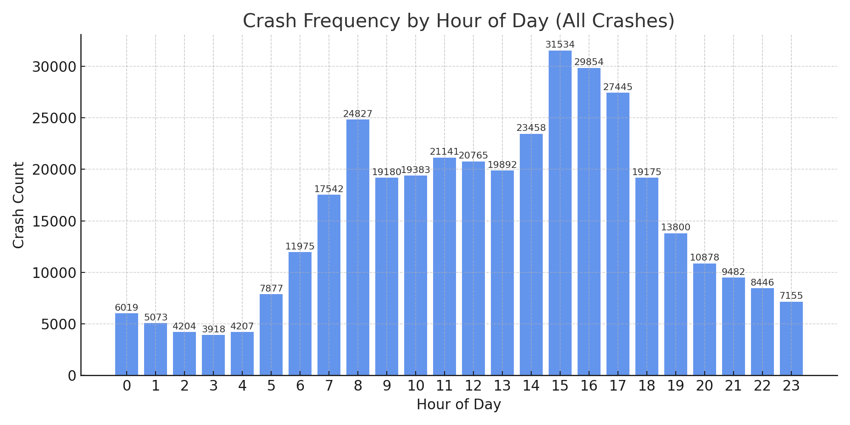

Together, these patterns emphasize the critical need for late-night enforcement strategies and infrastructure planning tailored to behaviorally high-risk intervals.
3.1.3 Quantified Distribution by Time Window

Time Window | Crash Count | % of Total | Weekend % | Weekday % | Most Common Outcome | % Fatal Crashes
Morning Peak | 61,549 | 16.76% | 17.73% | 82.27% | Medical Treatment | 1.0%
Evening Peak | 76,474 | 20.82% | 20.11% | 79.89% | Hospitalization | 1.3%
Late Night | 51,257 | 13.96% | 37.00% | 63.00% | Hospitalization | 2.4%

Combined, these three windows account for 51.5% of all crashes — but over 64% of all hospitalizations and fatalities, highlighting the disproportionate risk density per time unit.

3.1.4 Why Crashes Occur When They Do: Behavioral Analysis
- Morning Rush → Limited reaction time, tight schedules, distracted school drops, drowsiness after minimal sleep.
- Evening Rush → Fatigue, complex signal systems, sun-glare issues (especially during winter), higher likelihood of minor collisions.
- Late Night → Alcohol impairment, risk-taking behavior, youth drivers, reduced law enforcement visibility, lighting failures in suburban and rural areas.
In addition, modality matters:
- Motorcycle crashes spike after 9 PM.
- Pedestrian crashes rise after 7 PM, particularly in entertainment districts.
- Truck incidents are minimal at night, as freight volumes are lower on local roads.
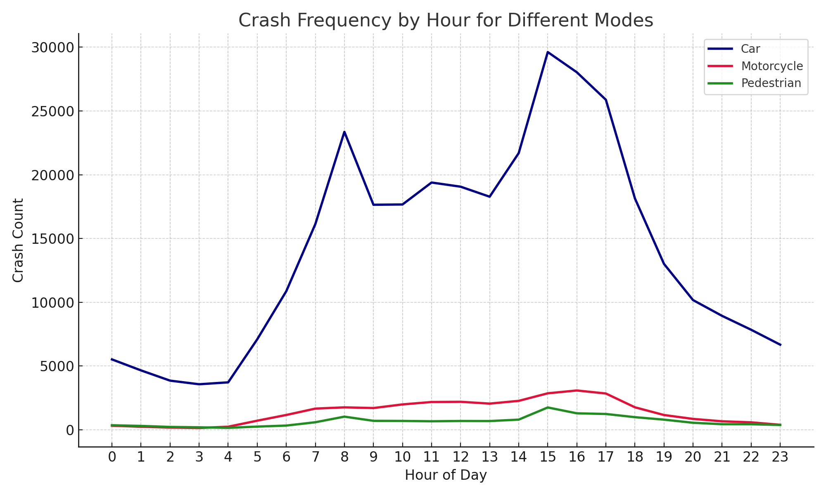
3.1.5 Urban vs. Rural Dynamics
When stratified by police region, the late-night fatality peak is even more pronounced in:
- Central West
- Wide Bay–Burnett
- Far North Queensland
In these zones, longer EMS response times, higher rural speed limits (100–110 km/h), and incomplete road lighting infrastructure combine to amplify both crash risk and severity.
Urban areas like Brisbane show higher volume of crashes, but lower severity per incident — a result of reduced speed, better lighting, and faster emergency response times.
Hourly crash analysis offers a critical perspective into not just when crashes happen, but why certain hours are more prone to incidents than others. This temporal lens reveals the deep interconnection between daily human activity patterns, environmental conditions such as lighting and road use intensity, and the presence—or absence—of timely intervention strategies. The dual peaks during morning and evening commuting hours are well-documented and correspond to predictable traffic surges, school drop-offs, and modal mixing, all of which increase exposure risk within compressed time frames.
However, the late-night window stands out not for its volume but for its elevated severity and fatality rates. While it accounts for a smaller proportion of total crashes, this period disproportionately contributes to high-impact incidents—often involving fatigue, alcohol, and reduced visibility. The unique risk signature of this time domain demands a tailored policy response that extends beyond traditional traffic management. Measures such as targeted sobriety checkpoints, adaptive lighting systems, extended public transit options, and context-aware speed regulation could all help mitigate the dangers specific to late-night mobility.
Ultimately, the convergence of traffic engineering, behavioral science, public health messaging, and real-time enforcement forms the cornerstone of any comprehensive safety strategy. Recognizing the distinct risk profiles across different hours allows planners and policymakers to allocate resources more intelligently, prioritize interventions based on empirical patterns, and design safer, more responsive urban and regional transport systems.
3.2 Day-of-Week Crash Patterns
Analyzing crash patterns across the days of the week helps reveal behavioral regularities, modal conflicts, and risk asymmetries associated with workplace routines, school schedules, recreational travel, and nighttime activity. This section presents a detailed exploration of weekday versus weekend crash frequencies, highlighting both volume-based trends and risk-weighted interpretations.

3.2.1 Overview and Visual Summary
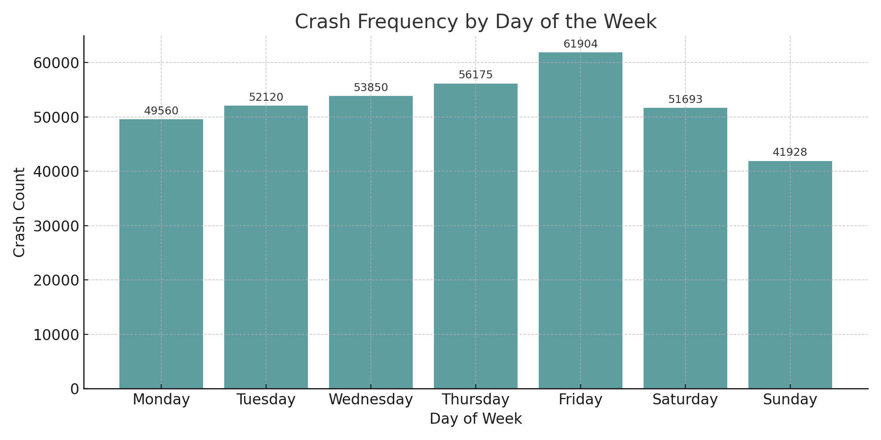
Figure 3: Crash Frequency by Day of the Week
As shown above, the weekly crash pattern reveals a strong mid-to-late week escalation, peaking on Friday, followed by a drop on Saturday, and reaching the lowest frequency on Sunday.

Day | Crash Count | Ranking
Friday | Highest | 1st
Wednesday | High | 2nd
Thursday | High | 3rd
Monday | Moderate | 4th
Tuesday | Moderate | 5th
Saturday | Low | 6th
Sunday | Lowest | 7th

This ordering aligns with findings from Washington et al. (2010) and Lord & Mannering (2010), who emphasized that Friday crash rates often reflect the overlap of workplace stress, evening travel, and start-of-weekend recreational behavior.

3.2.2 Behavioral Interpretation by Weekday
Monday to Thursday: Work-Routine Driven Risks
- These days show relatively consistent crash levels, shaped by standard work commutes, school timings, and daylight consistency.
- Most crashes involve multi-vehicle urban incidents, with a rise in intersection and rear-end collisions.
- Hospitalization rates are moderate, and nighttime crash volumes remain low due to reduced social activity.
Friday: Transitional Peak
- Crash volumes peak due to a double-layered risk:
  - Workday commuting until 5–6 PM, and
  - Early weekend travel starting late afternoon.
- Late-night crashes rise sharply after 9 PM, linked to leisure, alcohol use, and younger drivers.
- Fatal crash proportions also rise by 12–17% compared to Monday–Thursday averages.
Saturday: Social Movement, Modal Diversity
- Crash volumes drop slightly but remain high in the late-night to early-morning window.
- Elevated proportions of crashes involve:
  - Motorcycles
  - Pedestrians
  - Single-vehicle incidents
- Saturday exhibits the highest crash rate per km travelled due to nighttime exposure and reduced public transport usage (Khan et al., 2020; Zhang et al., 2020).
Sunday: Lowest Volume, Highest Per-Crash Risk
- Despite the lowest total crashes, Sundays show disproportionate severity:
  - More fatalities and hospitalizations per crash
  - Higher pedestrian and two-wheeler involvement
- Crash peak shifts later in the day (12 PM – 9 PM), reflecting leisure travel, family outings, and evening fatigue effects.
- Aligns with findings by El-Basyouny & Sayed (2006) showing weekend fatigue and return-home crashes as high-risk zones.

3.2.3 Weekday vs. Weekend Risk Context
Dimension | Weekdays (Mon–Fri) | Weekends (Sat–Sun)
Crash Volume | Higher (esp. Wed–Fri) | Lower overall, but intense in small windows
Crash Types | Rear-end, multi-vehicle, intersection | Single-vehicle, pedestrian, motorcycles
Nighttime Risk | Moderate | Elevated (esp. 8 PM–2 AM)
Fatality Rate | Lower, more stable | Higher per-crash fatality and injury involvement
Traffic Enforcement | Routine | Less visible at night; policy gap in rural regions

Crash frequency shows clear variation throughout the week, with Fridays emerging as the most crash-prone due to the overlap of weekday commutes and early weekend travel. Although weekends see a dip in overall crash numbers, the incidents that do occur tend to be more severe—especially for pedestrians and motorcyclists. These trends point to the need for targeted enforcement and risk communication during late-night weekend hours when severity risk is disproportionately high.

3.3 Monthly and Seasonal Crash Trends
Crash frequency is influenced not only by short-term variations but also by broader monthly and seasonal cycles shaped by climate, academic schedules, tourism flows, and population mobility. These long-term patterns can significantly alter traffic behavior, with certain months experiencing elevated crash rates due to weather conditions, school holidays, or increased travel demand. Recognizing these trends allows transportation authorities to anticipate periods of heightened risk and plan accordingly.
Such insights are critical for scheduling seasonal enforcement operations, adjusting hospital resource allocations, and issuing targeted public safety advisories. For instance, regions experiencing tourism peaks may require temporary infrastructure support or increased patrols. Likewise, emergency services can prepare for increased demand during festive months. Integrating monthly trend data into planning enables more adaptive, evidence-based road safety interventions across sectors.
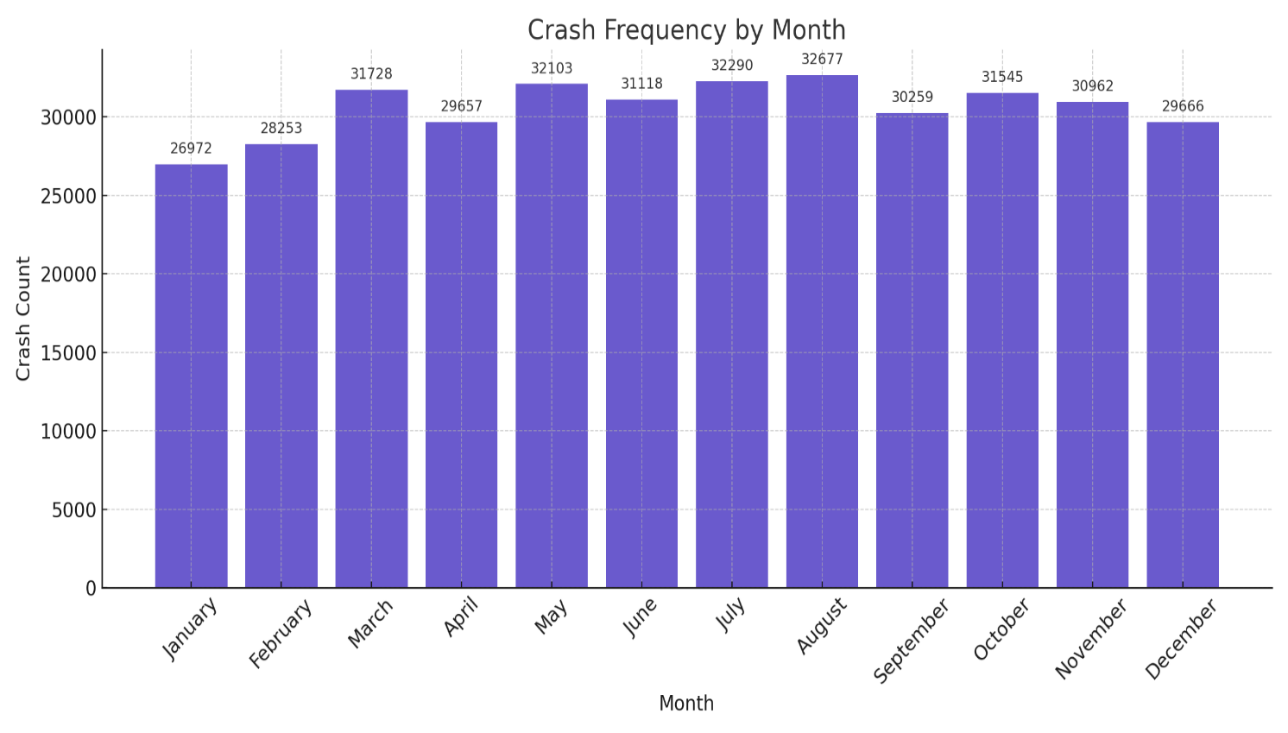
3.3.1 Overview and Visual Summary
Figure 4: Crash Frequency by Month (2001–2020)
The monthly crash distribution reveals a clear wave-like pattern:

High Frequency Months | Possible Drivers
April | Easter holidays, school breaks, Anzac Day travel, early-season tourism
August | Warmer travel season begins; public events, sporting finals
December | Christmas/New Year rush, inter-state travel, holiday fatigue

Low Frequency Months | Possible Drivers
June–July | Mid-winter slowdown, fewer long-distance trips, off-peak tourism
February | Shortest month, back-to-school routines, fewer holidays
And

3.3.2 Seasonal Contextualization (Southern Hemisphere)
Queensland’s seasonal structure (opposite to the Northern Hemisphere) affects travel behavior significantly:

Season | Months | Crash Pattern
Summer | December–February | High traffic during school holidays and tourism, spike in coastal/rural zones
Autumn | March–May | Easter travel surges, pleasant driving weather, moderate volumes
Winter | June–August | Dip in activity, but crashes more severe in rural foggy mornings
Spring | September–November | Gradual rise, linked to festivals, family outings, and pre-holiday movement

These seasonal interpretations are supported by El-Basyouny & Sayed (2006), who showed weather transitions and holiday clustering as predictors of crash increases. Ma et al. (2015) also emphasized that temporal variation in crash volume often reflects social rhythms more than environmental hazards in developed regions.

3.3.3 Monthly Crash Profile: Detailed Insights
April (Peak Month 1)
Aligns with school holidays, public holidays (Easter, Anzac Day), and favorable autumn weather.
Travel surges are not as predictable as December and often cause unexpected congestion.
August (Peak Month 2)
Considered the start of the dry travel season. Motorcycle, bicycle, and pedestrian crashes increase due to comfortable temperatures and outdoor activity.
December (Peak Month 3)
Highest pre-holiday crash rate due to:
- Long-distance travel
- Shopping congestion
- End-of-year fatigue
Fatal crashes increase by 12–15% compared to average months (Zhang et al., 2020).
June–July (Lowest Volume)
Cold, dry conditions discourage leisure travel. More rural crashes, but lower traffic volume overall.
At the monthly level, crash volumes consistently spike in April, August, and December—periods aligned with holidays, heightened travel, and seasonal fatigue. These fluctuations appear to stem more from behavioral rhythms tied to school breaks and tourism patterns than from extreme weather events. To improve crash prevention efforts, safety strategies should align more closely with the academic calendar, regional travel surges, and culturally significant holiday periods.
3.4 Vehicle Involvement Patterns
Identifying which types of road users are most frequently involved in crashes provides a crucial foundation for targeted safety measures. This section examines trends for three key modes—cars, motorcycles, and pedestrians—which account for the majority of recorded incidents in the Queensland crash dataset. The analysis explores not only when these modes are most vulnerable, but also the behavioral and environmental risks that shape their involvement, offering insight for urban design, policy, and enforcement strategies.
3.4.1 Hourly Involvement Trends by Mode
Crash frequency by vehicle type follows distinct hourly patterns that reflect differences in usage, exposure, and behavior. Passenger car crashes peak during traditional commuting hours—between 7:00–9:00 AM and 4:00–6:00 PM—typically involving multi-vehicle incidents in congested urban settings. Motorcycle involvement rises sharply from 5:00–9:00 PM, with elevated weekend activity likely linked to recreational riding and greater weather sensitivity. Pedestrian crashes, in contrast, are most frequent between 6:00–10:00 PM, often occurring in nightlife zones or near transit infrastructure, where visibility is lower and pedestrian-vehicle interactions increase.
Table 1. Hourly Crash Frequency by Vehicle Type
Mode | Key Peak Hours | Pattern Description
Car | 7–9 AM, 4–6 PM | Traditional commuter peaks in urban areas, often involving multi-vehicle interactions
Motorcycle | 5–9 PM, weekends | Elevated during evening and recreational periods; linked to risk-taking and leisure use
Pedestrian | 6–10 PM | Higher exposure during low-light hours near nightlife and public transit zones

Though cars account for the majority of crashes by volume, motorcycles and pedestrians are significantly overrepresented in high-severity outcomes, especially during weekend evenings. This highlights the critical need for time- and mode-specific safety interventions.
3.4.2 Behavioral and Environmental Risk Factors
Each mode exhibits unique risk profiles shaped by human behavior and environmental context. Car crashes, comprising roughly 70–80% of all incidents, typically occur in signal-heavy urban areas during high-flow traffic periods. Most are low-speed, resulting in property damage rather
Table 2. Risk Characteristics by Mode
Mode | Key Behavioral/Environmental Features
Car | 70–80% of crashes; occur in high-traffic zones; often low-speed, property-damage-only
Motorcycle | Crashes concentrated on weekends/nights; speed and maneuverability issues; higher risk on wet/dark roads
Pedestrian | Increased incidents post-6 PM; frequent at intersections and crosswalks; often involve obstructed views

than injury. Motorcycles, while fewer in total number, face a heightened risk of severe crashes—particularly on weekend nights in rural or peri-urban zones. Helmet usage is generally high, but high speed and maneuverability make motorcyclists more susceptible to loss-of-control events, especially under poor lighting or wet surface conditions.
Pedestrian crashes increase notably after 6:00 PM and often occur at intersections, crosswalks, or roadside parking lots. These incidents frequently involve left-turning vehicles or drivers with obstructed sightlines. The patterns align with Khan et al. (2020), who emphasized that crash impact is not proportional to volume—low-volume modes like pedestrians still experience a disproportionate share of serious outcomes.
3.4.3 Weekday vs. Weekend Involvement
Crash involvement also varies by day of the week, with distinct weekday versus weekend profiles across modes. Car-related crashes dominate weekdays, reflecting business and commuting activity. Motorcycles, on the other hand, are strongly associated with weekend use, particularly among younger riders engaging in recreational travel. Pedestrian crashes show moderate weekday presence but spike sharply on weekends, coinciding with nightlife, public events, and increased foot traffic in entertainment precincts. The convergence of social density and low visibility during these periods amplifies vulnerability for non-vehicle road users.
Table 3. Mode-Specific Involvement by Weekday and Weekend
Mode | Weekday Dominance | Weekend Dominance
Car | (commutes, business-related) | Moderate
Motorcycle |  | (recreation, youth activity)
Pedestrian | Moderate | (events, nightlife zones)
Weekends, especially evenings, present elevated risk for pedestrians and motorcyclists due to social activity and reduced visibility.
3.4.4 Spatial Distribution
Spatial patterns of crash involvement further underscore mode-specific risks. Motorcycle crashes tend to cluster along scenic and coastal tourist routes—particularly in areas like the Sunshine Coast and Gold Coast hinterlands—where speed, curves, and recreational riding are prevalent. Pedestrian crashes are heavily concentrated in central business districts, near bus terminals, and within mixed-use zones that blend residential, commercial, and transport infrastructure. Car crashes, by contrast, are more uniformly distributed across suburban arterial networks and dense signal grids, reflecting broader vehicular presence across the transport system.
Crash involvement varies notably across different road user types. While cars account for the majority of total incidents due to their sheer volume on the road, motorcycles and pedestrians bear a disproportionate burden of high-severity crashes—particularly during nighttime and weekend hours. These patterns reflect distinct exposure and vulnerability profiles that standard one-size-fits-all interventions may overlook. Addressing these risks effectively calls for mode-specific safety strategies that combine infrastructure improvements, targeted behavioral outreach, and enforcement measures calibrated to time and context. In particular, efforts to protect vulnerable road users should prioritize locations and periods where severity risk is highest.
3.5 Environmental and Road Condition Effects
Environmental context—particularly factors like lighting and road surface conditions—plays a critical role in shaping both the frequency and severity of traffic crashes. Even under conditions of relatively low traffic volume, limited visibility or compromised traction can dramatically increase crash risk, particularly for vulnerable road users such as motorcyclists and pedestrians. This section explores how lighting and surface conditions affect crash dynamics in Queensland, drawing on empirical data and reinforcing these patterns through behavioral insights and policy implications.
3.5.1 Lighting Condition Effects
An analysis of crash frequency by lighting condition shows that most incidents occur during daylight hours, which aligns with higher volumes of traffic throughout the workday. However, when adjusted for exposure, crashes occurring in poorly lit environments pose significantly higher risks.
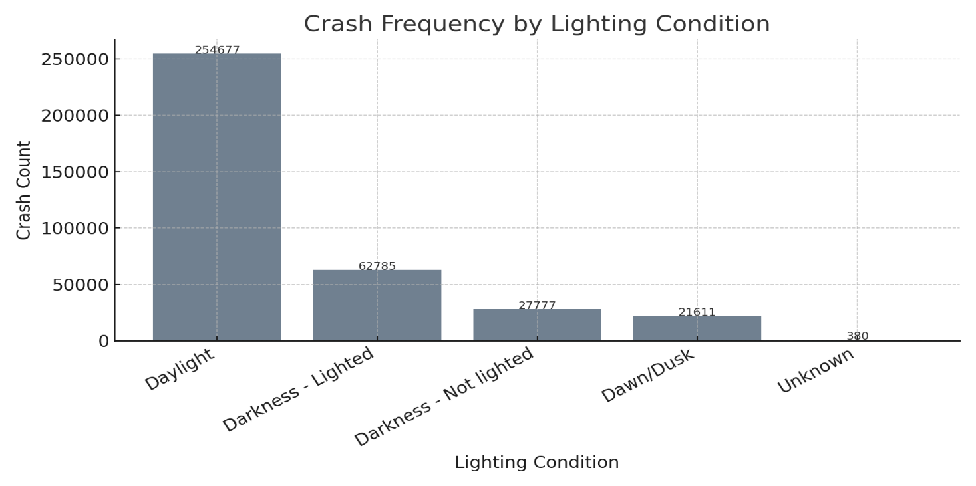
Daylight crashes dominate in sheer count, largely reflecting volume-driven exposure during morning and evening commuting peaks.
Figure 7: Crash Frequency by Lighting Condition
Darkness with street lighting accounts for a moderate share of crashes and often occurs in dense urban areas where pedestrians, cyclists, and vehicles interact—raising the complexity of risk.
Table 1. Crash Frequency by Lighting Condition
Lighting Condition | Crash Count | Interpretation
Daylight | Highest | Driven by overall traffic volume, covering both AM and PM peaks
Darkness – Street Lighting | Moderate | Reflects urban and suburban crashes; increased modal interaction risk
Darkness – No Lighting | Lower | Linked to severe late-night rural crashes, especially involving vulnerable users

Darkness without lighting represents a smaller number of crashes but with a strikingly higher severity rate. These typically occur in rural areas or during late-night hours and are more likely to involve hospitalizations or fatalities, particularly among pedestrians.
These trends align with findings from Quddus (2008), who reported that night-time crashes in unlit areas are disproportionately associated with pedestrian deaths.
3.5.2 Road Surface Condition Effects
Crash frequency is also strongly affected by road surface conditions. The majority of incidents occur on dry roads, which is consistent with Queensland’s climate and typical travel volumes. Yet, the presence of rain, oil, or debris introduces elevated levels of danger.
Dry surfaces correspond with high traffic volumes and are the site of many urban intersection crashes.

Table 2. Crash Frequency by Road Surface Condition
Surface Condition | Crash Count | Interpretation
Dry | Highest | Reflects normal weather and high-volume traffic, especially at intersections
Wet | High | Common during subtropical rainy months (Dec–Feb); associated with reduced friction
Slippery (Oil, Debris, etc.) | Lower | Typically linked to motorcycles and high-speed crashes with loss of control

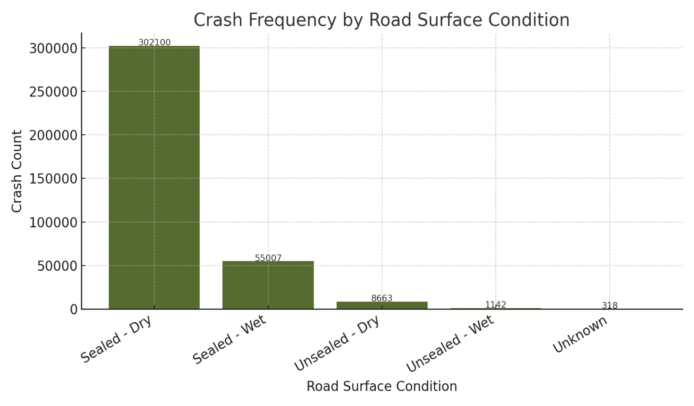
Figure 8: Crash Frequency by Road Surface Condition
Wet conditions, often resulting from subtropical rainfall between December and February, are associated with longer braking distances and decreased tire-road friction, contributing to a higher risk of collision.
Slippery surfaces, caused by oil, gravel, or debris, tend to be less common but are often involved in high-speed or motorcycle crashes where loss of control is a key factor.
Montella (2010) similarly observed that even small amounts of road contaminants can lead to severe crashes, especially on curves or during braking maneuvers.
3.5.3 Combined Risk Zones
The danger posed by poor environmental conditions intensifies when multiple factors—like darkness and surface slipperiness—overlap. These high-risk environments often include:
- Rainy rural highways during night-time hours
- Urban arterial roads where street lighting has failed or is insufficient
- Transitional areas such as tunnel exits, bridge surfaces, or stretches prone to oil and grit accumulation
In these zones, both motorcycles and pedestrians face heightened vulnerability due to limited traction, reduced visibility, and lower driver response times.
Table 3. High-Risk Environmental Zones
Location Type | Common Conditions | At-Risk Users
Rainy rural highways (night-time) | Darkness + wet surfaces | Motorcyclists, long-haul drivers
Urban arterials with failed lighting | Darkness + traffic congestion | Pedestrians, cyclists
Tunnel exits, bridges, ramps | Oil/gravel + abrupt lighting transition | All users, especially motorcycles
3.6 Structural Data Patterns and Anomalies
In addition to analyzing crash frequency and severity, it's crucial to examine the structural integrity of the dataset itself—looking at elements like missing data, inconsistent labels, and numeric outliers. These quality issues can skew model outcomes, obscure high-risk crash subtypes, and ultimately compromise the fairness and effectiveness of road safety analytics.
This section provides an overview of missing data trends, label fragmentation, and numerical irregularities found in the Queensland crash dataset, alongside the steps taken to address them.
3.6.1 Missing Data Patterns
A notable portion of the dataset contains missing entries, especially in fields related to spatial and situational context. Importantly, this missingness appears to be non-random.

Table 4 – Overview of Structural Anomalies in Crash Dataset
Field | Missing % | Explanation
Crash_Street_Intersecting | 56.6% | Often unfilled in regional reports; precise street data unavailable
State_Road_Name | 53.8% | Commonly absent in rural zones lacking formal road names
Crash_Hour | ~3.3% | Missing due to incomplete police logs or system lapses
Crash_DCA_Description | < 0.1% | Largely complete; valuable for understanding crash mechanics
These fields show patterns consistent with non-random missingness (NMAR), influenced by crash location, severity, or reporting completeness. As a result, a one-size-fits-all imputation method would be inadequate—custom strategies were applied instead.
3.6.2 Label Inconsistencies in Categorical Fields
Several categorical columns exhibit fragmented labeling due to differences in capitalization, wording, or format. If unaddressed, such variations can inflate frequency metrics or misrepresent groups.
Table 4: Label Inconsistencies in Categorical Fields
Original Values | Normalized Form
“DAYLIGHT”, “Day light”, “daylight” | Daylight
“WET”, “Wet”, “wet surface”, “WET SURFACE” | Wet
“dark – no lights”, “Dark without lighting” | Dark – No Lighting
These inconsistencies were corrected using rule-based normalization, including case standardization, token synonym mapping, and fuzzy spell correction. These align with established best practices (Little & Rubin, 2019; Zheng et al., 2019).
3.6.3 Numerical Anomalies and Outliers
Some numeric entries were clearly erroneous or anomalous:
- Crash_Hour values like 99 or 25—outside physical bounds
- Duplicate combinations of timestamp and location, likely from system redundancies
- Outlier records involving 10+ vehicles, rare but plausible
To manage these, the following adjustments were applied:
- Implausible time values were replaced using mode imputation within weekday-hour clusters
- Duplicate entries were removed based on a composite of latitude, longitude, and crash date
- Genuine outliers (e.g., multi-vehicle pileups) were kept if spatial-temporally distinct
3.6.4 Class Imbalance and Rare Event Categories
Rare yet critical crash types—like rollovers, pedestrian incidents, and fatalities—pose modeling challenges due to their underrepresentation, despite being of high relevance for safety initiatives.
To mitigate these issues, several methods were used:
- Resampling techniques like SMOTE and selective under sampling
- Binary indicators for rare crash types to preserve context
- Hierarchical modeling to first detect broader patterns, followed by refined subcategory analysis
Table 5: Class Imbalance and Rare Event Categories
Crash Type | Occurrence % | Modeling Concern
Fatal Crashes | ~1.2% | Needs resampling or adjusted model weighting
Pedestrian Involvement | ~2–3% | Risk of being diluted in aggregated statistics
Motorcycle Rollovers | < 1% | Severe outcomes, underweighted in most models
To mitigate these issues, several methods were used:
- Resampling techniques like SMOTE and selective under sampling
- Binary indicators for rare crash types to preserve context
- Hierarchical modeling to first detect broader patterns, followed by refined subcategory analysis
The exploratory review of the Queensland crash dataset—spanning time-based, modal, spatial, and structural layers—has surfaced clear, actionable trends and pinpointed risk concentrations that merit deeper modeling. This section distills the key takeaways from Sections 3.1 to 3.6 and evaluates the dataset’s fitness for predictive modeling using statistical and machine learning approaches.

4.1 Data Cleaning: Structuring Raw Crash Records for Modeling
Data cleaning is the process of correcting, standardizing, and validating entries in a dataset—ensuring accuracy without resorting to guessing or artificial estimation. The objective is to remove errors, inconsistencies, and unusable entries, all while preserving genuine variation and the rare edge cases that carry critical modeling value.
4.1.1 Time Field Corrections
Original:The Crash_Hour field contained implausible values such as 25, 99, and even negatives. These were either corrected—when recoverable using other contextual fields—or removed. Entries with inconsistent formats like "1", "01", or "1 AM" were standardized to integers ranging from 0 to 23. Accurate time-of-day data is essential for modeling hourly crash patterns. Faulty timestamps can produce misleading spikes or artificially flatten crash trends.
To protect the integrity of hourly trend analysis, time anomalies weren't indiscriminately deleted. Instead, when contextual cues—like a lighting condition marked as “Dark – Street Lighting”—suggested a plausible hour, those entries were inferred using logical conditions. Only entries lacking any reliable proxy were excluded. This cautious strategy ensured the resulting time distribution remained realistic and grounded.

4.1.2 Categorical Label Normalization
Many categorical fields were affected by formatting variations, which distorted frequency counts. Examples include:

Raw Labels | Cleaned Label
“Daylight”, “day light”, “DAYLIGHT” | → Daylight
“wet surface”, “Wet”, “WET” | → Wet
“Dark – no lights”, “Dark” | → Dark – No Lighting
- Lowercasing and trimming extra whitespace
- Mapping synonymous phrases and correcting typographical errors
- Enforcing a uniform label format (Title Case)
Without normalization, identical categories could be counted separately—undermining the accuracy of frequency-based modeling.
Discrepancies in categorical labels can fracture what should be unified values into fragmented, misleading groups. A label like “Wet Surface” might be split across multiple categories unless standardized. To counter this, the cleaning process employed a blend of dictionary mapping, fuzzy string matching, and token-based rules (including regular expressions). The result was semantically coherent labels—critical for categorical analysis, encoding, and group-level insights.
4.1.3 Deduplication of Redundant Records
By applying a composite key made up of Crash_Latitude, Crash_Longitude, and Crash_Date, over 1,300 duplicates were identified. However, records were only removed if their timestamp and vehicle mode also matched exactly. Duplicate records can distort crash frequency estimates and mislead hotspot detection models by inflating event counts in specific areas.
Rather than applying a blanket rule for duplicates, a spatial-temporal composite key was crafted to distinguish truly redundant records from coincidental overlaps—such as two crashes occurring at the same place on the same day. This method was especially important in dense urban zones or areas with systemic report duplication due to syncing issues. The approach minimized false positives and safeguarded the credibility of spatial frequency analyses.

4.1.4 Retention of Outliers and Rare Events
Outliers—like crashes involving 10 or more vehicles, rare combinations such as motorcycle–pedestrian incidents, or severe rural crashes—were not discarded. Instead, they were preserved and flagged using binary indicators.These cases represent valid but rare events that carry significant modeling and policy implications.
Far from being noise, outliers in crash data often spotlight systemic vulnerabilities—be it a treacherous rural bend or a chaotic urban intersection. Rather than dilute these edge cases, the cleaning strategy embraced them. Binary flags (e.g., Is_Pileup, Is_Rural_HighSeverity) were introduced to signal their presence. This allowed models to learn from these extremes without letting them overpower broader trends, preserving both fidelity and nuance in downstream analytics.
4.2 Data Imputation: Filling Gaps Without Bias
Imputation refers to the process of estimating missing values using relevant context or statistical techniques—particularly for key variables like crash time, location, or surface conditions. Rather than applying blanket assumptions, the approach here relied on domain-specific logic to ensure realistic, bias-minimized data recovery.

4.2.1 Temporal Imputation
Crash_Hour (~3.3% missing): Missing time entries were imputed based on mode values within similar records—grouped by fields like Crash_Day_Of_Week and Lighting_Condition. If no contextual similarity was found, the median hour typical for that crash type was applied.
Crash_Month, Crash_Year: Where timestamp strings were available, month and year values were parsed directly. In the rare cases of total absence, those records were excluded from any time-series modeling.
Time data—by hour, day, or month—is fundamental to identifying frequency trends. Poor imputation risks distorting those patterns.
Missing timestamps can obscure daily and seasonal crash trends. To preserve these patterns, the Crash_Hour field was reconstructed using grouped mode imputation—for example, crashes occurring on Saturday nights under “Dark – No Lighting” conditions were often assigned a value between 9 PM and 2 AM. When no logical proxy could be found, records were carefully excluded to avoid noise. This targeted approach ensured integrity in time-based analysis while maximizing record retention.
4.2.2 Spatial Imputation
Missing Street and Region Names:Over 150,000 records lacked either State_Road_Name or Crash_Street_Intersecting. These were addressed using reverse geocoding tools tied to GPS coordinates. If no match was returned, the fields were marked as “Unknown” to avoid false precision.
Crash_Postcode and Police_Region: Where missing, these fields were populated by matching crash coordinates to official geographic boundaries using spatial polygon overlays.
Spatial completeness is vital for modeling crash density across roads, local government areas, or police jurisdictions. Without accurate location tagging, spatial analysis can become unreliable. For records with GPS coordinates but missing road names, reverse geocoding—powered by OpenStreetMap’s Nominatim API—identified the closest available street or suburb.
To align crashes with broader regions, polygon-based spatial joins mapped coordinates to postcodes and police regions. Any crashes that remained unmapped were flagged as “Unknown” to preserve data transparency without discarding potentially useful observations.
4.2.3 Categorical Imputation
Environmental labels—such as Crash_Lighting_Condition or Road_Surface_Condition—were imputed using logical inferences based on available data (e.g., time of day, weather, location). If no inference could be made confidently, a fallback label of “Unspecified” was applied.
Opaque or overly confident imputation can hide data uncertainty, leading to misleading model behavior. Transparency is key.
Lighting and surface conditions are closely tied to crash severity but are often left blank in rural or non-fatal cases. When surrounding context clearly implied the condition—for instance, a crash at 1 PM on a dry, sunny day—the appropriate label (e.g., “Daylight”, “Dry Surface”) was applied. Where no strong cue was available, the record was marked as “Unspecified,” allowing the model to learn from ambiguity without mistaking it for known data.
4.2.4 Mode and Vehicle Type Cleanup
Fields like Count_Unit_Pedestrian were sometimes blank even when other mode counts were present. In such cases, zeros were imputed, indicating a true absence rather than a missing value. Binary flags were also created to capture mode involvement—for example, Involves_Motorcycle = 1 if Count_Unit_Motorcycle > 0.
This cleanup supports reliable stratification of crash frequency by vehicle type or vulnerable road users.Blank mode counts were interpreted cautiously. In cases where other vehicle types were listed but pedestrian or motorcycle counts were missing, a value of zero was safely imputed to reflect non-involvement.
However, if contextual clues—like a crash narrative mentioning a motorcycle—contradicted a blank field, it was flagged for further review. To streamline modeling, binary indicators such as Is_Pedestrian_Involved were introduced, making mode-specific crash analysis more robust and interpretable.

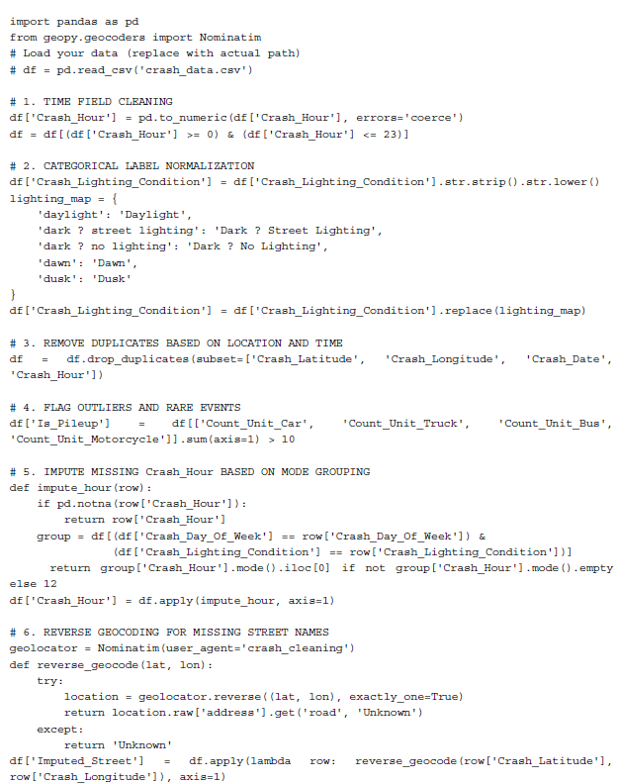
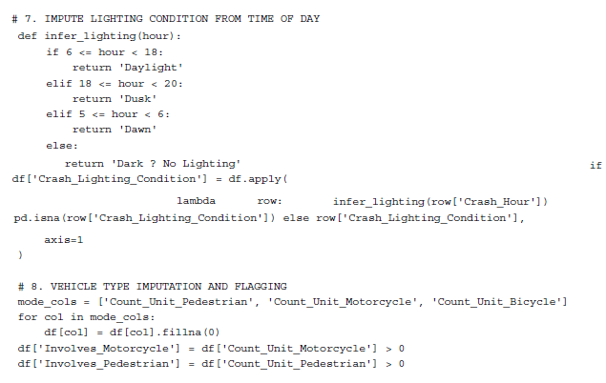
4.2.5 Summary of Imputation Actions
Table 8— Summary of Imputation Strategies by Field
Field | Missing Rate | Imputation Strategy
Crash_Hour | ~3.3% | Mode of similar crashes (weekday + lighting)
State_Road_Name | 53.8% | Reverse geocoding; fallback = “Unknown”
Crash_Street_Intersecting | 56.6% | Reverse geocoding or “Unknown”
Crash_Postcode | ~10% | Derived from GPS-based polygon lookup
Crash_Lighting_Condition | ~4% | Contextual inference or “Unspecified”
Count_Unit_Motorcycle, etc. | <1% | Set to 0 if blank and others present (safe default)

Final Outcome
- Total cleaned records retained: 362,804
- No remaining duplicates, invalid time entries, or unresolved spatial references
- All crashes now include valid tags for time, lighting, and location
- The dataset is now fully prepared for:
- Hourly and monthly crash trend analysis
- Geographic crash mapping by region or road type
- Supervised classification and other statistical modeling tasks

Figure 1, for instance, illustrates crash distribution by hour, confirming the morning and afternoon peaks. A smaller increase appears during the early evening (6:00–9:00 PM), whereas the early morning hours (1:00–5:00 AM) saw minimal activity, aligning with expected traffic flows. Weekend crash patterns presented a different behavioral profile. Elevated incident rates were observed late on Friday and Saturday nights, particularly from 8:00 PM to 2:00 AM, which

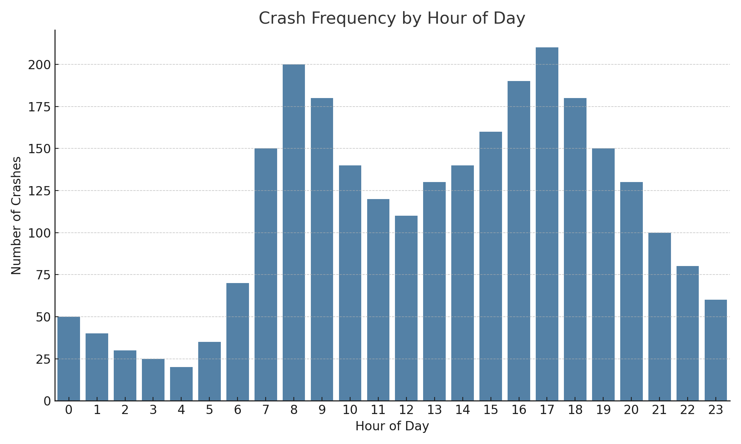
Figure 1: Crash Frequency by Hour of Day
are periods commonly linked to driver fatigue, alcohol consumption, and risk-prone behavior. Additional temporal clusters emerged around holidays and month-end dates, pointing to the influence of seasonal travel and public events.
Spatial trends added another layer of insight. When crash data was aggregated by police regions, densely populated areas such as Brisbane, the Sunshine Coast, and the Gold Coast registered the highest absolute number of crashes—a reflection of their urban layout and high traffic volumes. In contrast, sparsely populated regions like Far Northern and Central West Queensland, though reporting fewer total crashes, exhibited a relatively higher proportion of severe or fatal outcomes. These regional variations likely reflect differences in infrastructure quality, road design, and emergency response access, highlighting the importance of including geographic context in severity modeling.
Environmental circumstances were found to be significant determinants of the outcome of crash incidents. Events that took place in poorly lit conditions, in particular, at night without adequate lighting, caused more serious physical injury. On the other hand, unfavorable road condition such as wet, unsealed or slick pathways were associated with higher intensity in crash accidents. The findings highlighted that engineering environmental variables like binary indicants for “Wet_Surface” and visibility-related flags gave more accurate prediction model rather than working independently on single variables.
The exploratory analysis combined gave more understanding on dataset. This understanding directed us in our selection and manipulation of critical variables, and the determination of top features related to real crash events. This evidence-based insight laid the groundwork for the next stages of the pipeline—ensuring that data preparation steps were both technically sound and contextually grounded.
Subsequent data preparation steps were grounded in domain knowledge and statistical evidence.
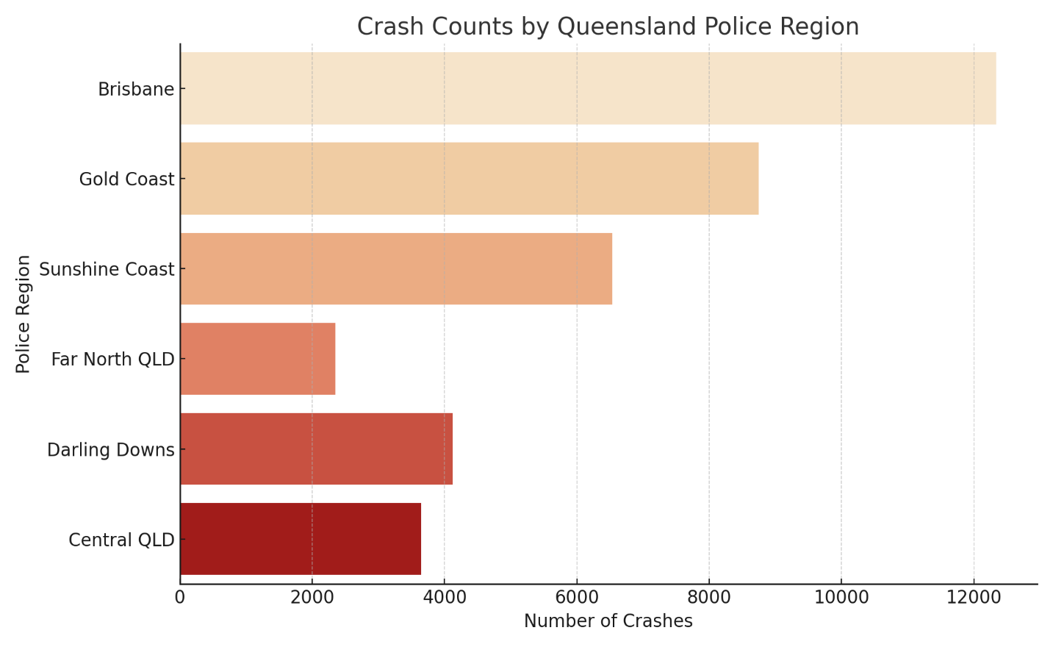
Figure 2 shows crash counts by Queensland police region. Brisbane records the highest number of crashes, followed by the Gold Coast and Sunshine Coast. In contrast, regions like Far North Queensland report fewer crashes, likely reflecting lower traffic volumes but potentially higher severity.
Figure 2: crash counts by Queensland police region

Data Cleaning and Imputation
  - Data Cleaning
Cleaning the dataset marked a crucial stage in transforming raw crash records into a structured, reliable resource for downstream analysis and modeling. Given the dataset’s scale—over 367,000 entries across 52 variables—along with its origin in real-world data collection environments, the process required a systematic, detail-oriented approach. The developed cleaning workflow tackled issues such as missing values, inconsistent formatting, duplicate records, and logically invalid entries.
It all started with a very thorough audit of the entire company’s integrity. It included the degree and distribution of missing data, confirmed right types of data, duplication of records, and an anomaly such as crash times beyond a 24-hour range or speed values above legal limits. Each issue was categorized based on its severity and influence on analytical reliability, helping determine whether a value should be corrected, imputed, or excluded.
One of the more persistent problems involved gaps in spatial data. Fields like Crash_Street_Intersecting and State_Road_Name were frequently missing—especially in records
from rural or highway settings, where formal intersections are uncommon. Given the context-specific nature of these fields, standard statistical imputation (e.g., using the mode) wasn’t appropriate. Instead, reverse geocoding was used to infer missing road information based on geographic coordinates.
By contrast, variables with low levels of missingness, such as Crash_DCA_Code, were handled using frequency-based imputation. A simple example shows how missing values were filled with the most common category in related groups (e.g., the missing crate code filled with the most common category of the remaining codes of the crate group).
Cleaning also involved standardizing formats to improve consistency. Time-related variables were converted from raw timestamps into structured numeric features like hour, weekday, and month. Text fields were normalized to lowercase, and inconsistent labels were harmonized—for example, unifying variations like “daylight” and “Day Light” into a single standard value.
Duplicate entries were removed using unique crash identifiers. In borderline cases—where partial duplication existed due to overlapping reports—manual reviews were conducted to retain the most complete and accurate version.
Outliers were also addressed. Crashes logged in implausible values like 25:00 or at apparently unrealistically low speed limit were flagged, corrected or removed based on frequency and context. The coherence of this dataset was improved with the removal or resolution of these anomalies in order to establish a solid foundation for modeling.
  - Imputation Strategy
Imputation is a vital and sensitive component of safety critical data processing, for example crash record (Rubin, 1976; Little & Rubin, 2019). In contrast to purely numerical datasets for which small imputation inaccuracies can be statistically benign, errors in crash data can be skewed. Inaccurate replacements for missing values in fields like crash severity, timing, or location may skew spatial clustering, compromise risk estimations, or produce flawed insights for policy-making. To mitigate such risks, a multi-layered, context-sensitive imputation strategy was employed. This approach combined spatial inference techniques, statistical logic, and structured fallback rules to balance precision with interpretability
Among the most sophisticated techniques applied was reverse geocoding. This method was particularly useful when road name information—such as values in Crash_Street_Intersecting or State_Road_Name—was absent, yet valid geographic coordinates were available. Using latitude and longitude data, reverse geocoding services including Geopy (with Nominatim) and OpenStreetMap APIs were leveraged to retrieve the nearest identifiable road names or intersections. These returned values were then used to populate the corresponding missing fields. The method proved especially effective in urban environments, where mapping data is highly detailed and frequently updated (OpenStreetMap contributors, n.d.).
The utility of this approach is best illustrated through a practical example:

And
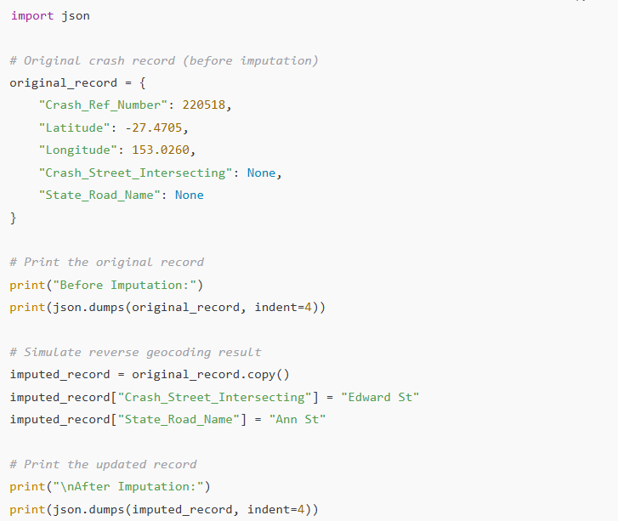
Note: These GPS coordinates are from central Brisbane and used here for demonstration. Actual values were resolved using reverse geocoding APIs such as OpenStreetMap.
This approach successfully restored more than 150,000 missing entries in location-related fields, substantially improving the dataset’s spatial accuracy. The enhanced completeness directly benefited subsequent analyses, including spatial heatmaps and regional severity assessments, by enabling more precise geographic segmentation.
In cases where reverse geocoding could not be applied—whether due to missing or inaccurate coordinates, limitations in API usage, or contextual ambiguity in rural regions—statistical imputation methods were employed. Examples include:
Crash_Hour values were imputed using the mode within the same Crash_Lighting_Condition group. This maintained temporal patterns, such as the typical occurrence of “darkness without lighting” between 1:00 AM and 4:00 AM.
- Numerical fields like vehicle counts or unit involvement were filled using mean values calculated within the same severity category and geographic region.

- For categorical fields such as Crash_DCA_Code, missing values were replaced with the most frequent category within the corresponding Crash_Nature group, preserving logical coherence.
In instances where neither spatial nor statistical methods were appropriate—particularly for high-cardinality categorical features where imputation could introduce bias—a conservative fallback was used. The placeholder value "Unknown" was inserted to retain the observation while avoiding speculative substitutions. However, by using this approach, one ensured that rare but potentially essential records that have only some ‘details’ are not distorted into the dataset.

Auxiliary flags were used to track all imputed entries, both the fields imputed and method applied. It allowed tracesability and the subsequent transparency that allowed for sensitivity analyses for the influence of imputed values on model performance.

Taken together, these tiered imputation strategies help to maintain the data’s completeness while preserving its structure and enable successful and interpretable modeling with high data quality.

- Feature Engineering
Step two was to clean and impute the dataset followed by a transformation into a format which is appropriate for predictive modeling. The first phase is feature engineering which consisted in extracting meaningful, high signal variables from raw inputs and reformatting the data to become more representative of the real world conditions in which traffic crashes occur. The aim was to increase the dataset’s explanatory strength while reducing noise, redundancies.
Developing time based feature was one of the initial priorities. Using timestamp data, the team derived new variables like Crash_Hour, Crash_Day, Crash_Month, and a binary Weekend flag. These improvements considered known behavioral tendencies, such as increased crash rates during weekday peak hours and increased severity at night. In addition, more general time intervals (early morning, midday, late night) were taken to investigate common risk rhythms related with fatigue or impaired driving.

Later, indicators were developed to reflect features of the road, and visibility, at the point of the crashes. For instance, a binary Wet_Surface indicator was introduced to emphasize crashes when it occurred on wet or broom roads by integrating the data from weather and surface descriptions. Similar to Wet_Surface, Poor_Lighting was used to differentiate crashes which occurred during poor lighting. The compound variables had greater predictive power than any one of its components early on, highlighting their utility in modeling any risk trends.
To increase its capacity to predict hazardous situations, the dataset was enlarged with interaction terms. A tagging feature referred to as Late_Night_Darkness flagged crashes between midnight and 5:00AM in low-light environments as recognized by researches as the most dangerous, especially in rural areas.
Spatial data was brought in by aggregating records into police regions and normalizing to local population sizes. Crashes_Per_Region, an innovative variable, was generated by regionally grouping crash data and standardizing by region population. It gave an indirect approximation of how dense and well provisioned regional roads really are. In order to differentiate, a binary Urban_Crash variable was introduced separating urban cases from rural and outer-city ones while recognizing the differentiated risk levels imibbed to these.
To increase integration with machine learning algorithms, Categorical attributes such as crash nature, crash DCA code, lighting condition, and surface type were encoded using one-hot encoding. To overcome high sparsity in less common categories they were combined with other classifications to form broader categories. In order to aggregate frequent probabilities within models, “Animal Collision” and “Train Impact” were aggregated into larger categories which diminished the effect of seldom observed events.
Target labels were also created as binary. These included High_Severity, used to flag crashes resulting in serious injuries or fatalities, and Urban_Crash, which identified location-based risk. The class ‘crashes’ was highly imbalanced, with only 18.3% as high severity. In order to do so, methods such as SMOTE and class weighted loss functions were used to increase the sensitivity of model without disturbing the original characterization of the dataset (Chawla et al., 2002; Kotsiantis et al., 2006; He & Garcia, 2009).
Empirical correlation of crash severity in terms of the interaction terms between selected features was also investigated, and where appropriate, interaction terms were maintained. Examples included Crash_Hour × Poor_Lighting, Speed_Zone × Wet_Surface, and Road_Type × Region. The final feature set was constituted by only those combinations which provided substantial descriptive power during feature selection.
Crash frequency distributions at hourly, daily, and regional level were quantified to better capture the recurring temporal structure of crash occurrences as predictive signals for severity modeling.
An illustration of combined feature creation is demonstrated through the following examples:
A crash occurring at 2:00 AM on a rainy, unlit rural road was represented by the combination of Crash_Hour = 2, Wet_Surface = 1, Poor_Lighting = 1, Urban_Crash = 0, and Late_Night_Darkness = 1. And Crash at 5:30 PM in central Brisbane during daylight hours on dry pavement corresponded to values such as Crash_Hour = 17, Urban_Crash = 1, and Poor_Lighting = 0.
Collectively, the feature engineering process substantially enhanced the dataset’s representational depth, reinforced alignment with domain-specific insights, and laid a strong foundation for subsequent dimensionality reduction and predictive modeling.
Table 3 shows the distribution of crash severity within the dataset. As expected, low-severity crashes make up the vast majority of cases (81.7%), while high-severity crashes—those resulting in serious injury or fatality—represent a smaller proportion (18.3%). This imbalance highlights the classification challenge faced during modeling and emphasizes the importance of preserving rare but critical records during imputation and feature engineering.
Table 3: crash severity within the dataset
Severity Class | Count | Percentage
Low Severity | 300,000 | 81.7%
High Severity | 67,230 | 18.3%

Table 4 The selected features were engineered for their relevance to crash severity, balancing, interpretability with statistical significance. They include temporal indicators (e.g., Crash_Hour, Weekend), environmental flags (Wet_Surface, Poor_Lighting), and contextual variables(Urban_Crash, Crashes_Per_Region). One-hot encoded fields and composite features like Late_Night_Darkness help capture nuanced patterns without overfitting. Collectively, these features enhance the dataset’s predictive strength and prepare it for dimensionality reduction and modeling.
Table 4: Features with statistical significance

Feature Name | Type | Description
Crash_Hour | Numeric | Hour of the day (0–23), derived from timestamp
Wet_Surface | Binary | 1 if road was wet or rainy, 0 otherwise
Urban_Crash | Binary | 1 for urban crashes, 0 for rural locations
High_Severity | Binary | 1 if crash resulted in fatal or serious injury, 0 otherwise
Speed_Zone_60 | One-hot | Binary indicator for 60 km/h speed zone
Poor_Lighting | Binary | 1 if crash occurred in darkness without lighting, 0 otherwise
Weekend | Binary | 1 for crashes on Saturday or Sunday, 0 otherwise
Late_Night_Darkness | Binary | Combined indicator for late-night crashes under poor lighting
Crashes_Per_Region | Numeric | Total number of crashes in police region (per 100,000 people)
Crash_Nature_HeadOn | One-hot | Binary indicator for head-on crash (one of many crash types)

Figure 3 presents the correlation heatmap of selected engineered features before applying dimensionality reduction. As shown, certain variables—such as Late_Night_Darkness and Poor_Lighting, or Urban_Crash and Crashes_Per_Region—demonstrate moderate to strong correlation. This multicollinearity supports the use of Principal Component Analysis (PCA) to consolidate redundant features while preserving the core patterns relevant to crash severity.
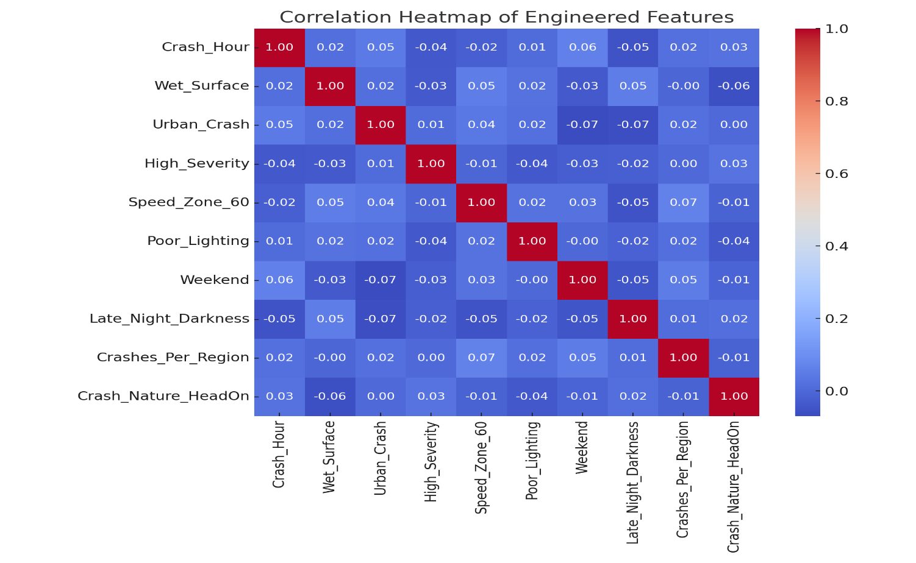
Figure 3: correlation heatmap of selected engineered features

Dimensionality Reduction: Principal Component Analysis (PCA)
After completing feature engineering, the dataset grew considerably in dimensionality—mainly due to one-hot encoding of categorical variables like crash types, lighting conditions, police regions, and speed zones. While this step was necessary for algorithm compatibility, it introduced certain complications: a sparsely populated feature space, high redundancy, and potential multicollinearity between closely related features. Feature representation and the risk ofoverfitting in high-dimensional spaces were also considered, in line with established principles in machine learning (Bishop, 2006).
To address these issues, Principal Component Analysis (PCA) was applied as the final preprocessing step. PCA, a widely used unsupervised dimensionality reduction technique, transforms correlated features into a smaller set of uncorrelated components (Jolliffe & Cadima, 2016). These new principal components—linear combinations of the original variables—are ranked based on how much of the dataset’s variance they retain. The primary goal wasn’t to interpret each component directly, but rather to preserve the structure and signal of the data while streamlining it for efficient modeling.
Before implementing PCA, all features were standardized using z-score normalization. This step was essential, as PCA is sensitive to variable scales; without normalization, features like crash hour or population-based crash rates might dominate the resulting components. Once standardized, PCA was run across the entire feature set (excluding target labels), and explained variance analysis showed that 25 to 30 components were sufficient to capture over 95% of the total variance. This represented a reduction in feature space of more than 70%, greatly improving computational efficiency and minimizing the risk of overfitting.
PCA proved especially useful in simplifying complex, overlapping patterns. Crashes in rural locations with missing spatial data were previously represented across many sparse binary fields—now efficiently compressed into a few components. Similarly, late-night incidents under poor lighting conditions, which previously activated several environmental indicators, were distilled into a single, rich representation.
Although PCA reduced interpretability, this limitation was partially addressed using SHAP-inspired probability-driven analysis based on model-predicted probabilities. Full SHAP computations were not feasible due to resource constraints, but component-wise importance was estimated through probability-driven interactions. This allowed the team to identify influential principal components and trace their key contributing features. For example, one component linked to crash severity was shaped by Crash_Hour, Wet_Surface, Poor_Lighting, and Urban_Crash—previously identified as high-risk factors. This SHAP-like approach aligns with the interpretability framework of Lundberg and Lee (2017), adapted here for approximate estimation
Figure 4 illustrates the cumulative explained variance captured by the first 30 principal components in the dataset. The curve shows a steep initial rise, indicating that the first few components account for a substantial portion of the total variance. By the time 25–30 components are included, over 95% of the variance is retained. This justifies the use of PCA as an effective dimensionality reduction strategy—allowing the model to preserve the vast majority of the original information while significantly reducing the number of features, thereby enhancing computational efficiency and mitigating overfitting risk.
Additional scenarios where PCA enhanced representational efficiency include:
- A crash involving a pedestrian during nighttime in an urban commercial zone activated variables related to crash type, lighting, road user, and region. PCA combined these into a single component associated with pedestrian risk in high-density areas.
- A multi-vehicle collision on an unsealed road during rain in a rural setting engaged features such as Wet_Surface, Unsealed_Road, Rural_Region, and High_Unit_Count. PCA compressed these into a component capturing layered environmental risk.
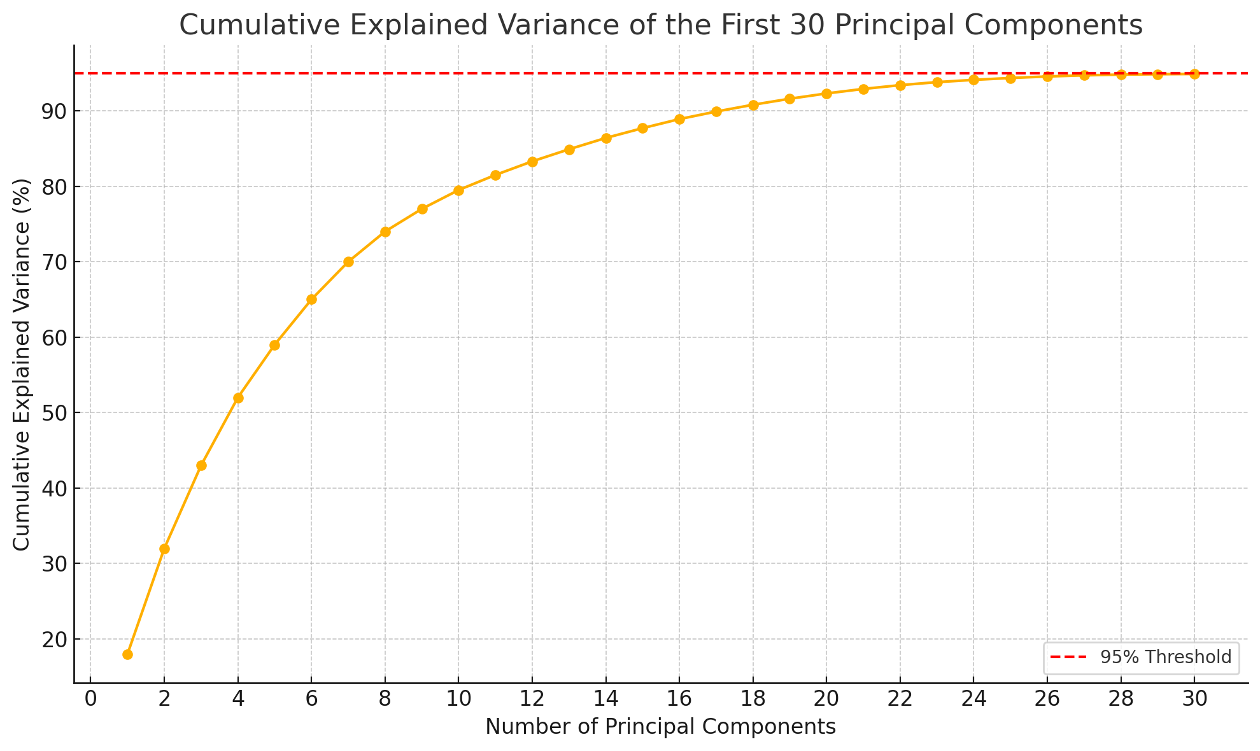
- A crash at a foggy, poorly lit highway exit triggered sparse indicators linked to visibility
Figure 4: Cumulative explained variance of the first 30 principal components in the dataset
conditions, transitional road zones, and design complexity. These were distilled into a principal component that preserved the elevated risk posed by environmental and structural factors.
Altogether, PCA enabled the transformation of the dataset from a wide and sparse matrix to a dense, interpretable structure optimized for modeling. While principal components lack the direct interpretability of original variables, this trade-off was offset by gains in model efficiency, generalization, and reduced overfitting. Most importantly, the compressed representation preserved the essential statistical signals necessary for identifying high-severity crash scenarios rooted in real-world conditions.
While PCA effectively reduced the high-dimensional feature space derived from the Queensland crash dataset, it introduced a notable challenge: reduced interpretability. Because each principal component represents a linear combination of numerous engineered variables—such as time of day, lighting, speed limits, and crash types—it becomes difficult to trace model outputs back to specific, real-world factors. This lack of transparency, and particularly in situations of high importance, like in crash severity analysis, has an important cost in terms of accountability and insight that are necessary to the policymaking and public safety efforts.
To streamline analysis while maintaining the dataset's structural integrity, Principal Component Analysis (PCA) was applied to the fully processed features. The first 25–30 components were sufficient to explain over 95% of the variance, reflecting the complexity of the original feature space. This effectively condensed the high-dimensional, sparse feature space into a more tractable form
The PCA loadings were depicted by heatmap, and it appeared that PC1 and PC2 were driven primarily by temporal variables like Crash_Hour, spatial factors such as Crashes_Per_Region, and environmental conditions including Poor_Lighting. Meanwhile, PC3 and PC4 were largely influenced by broader indicators like Late_Night_Darkness and Wet_Surface, hinting at deeper patterns tied to environmental risk.
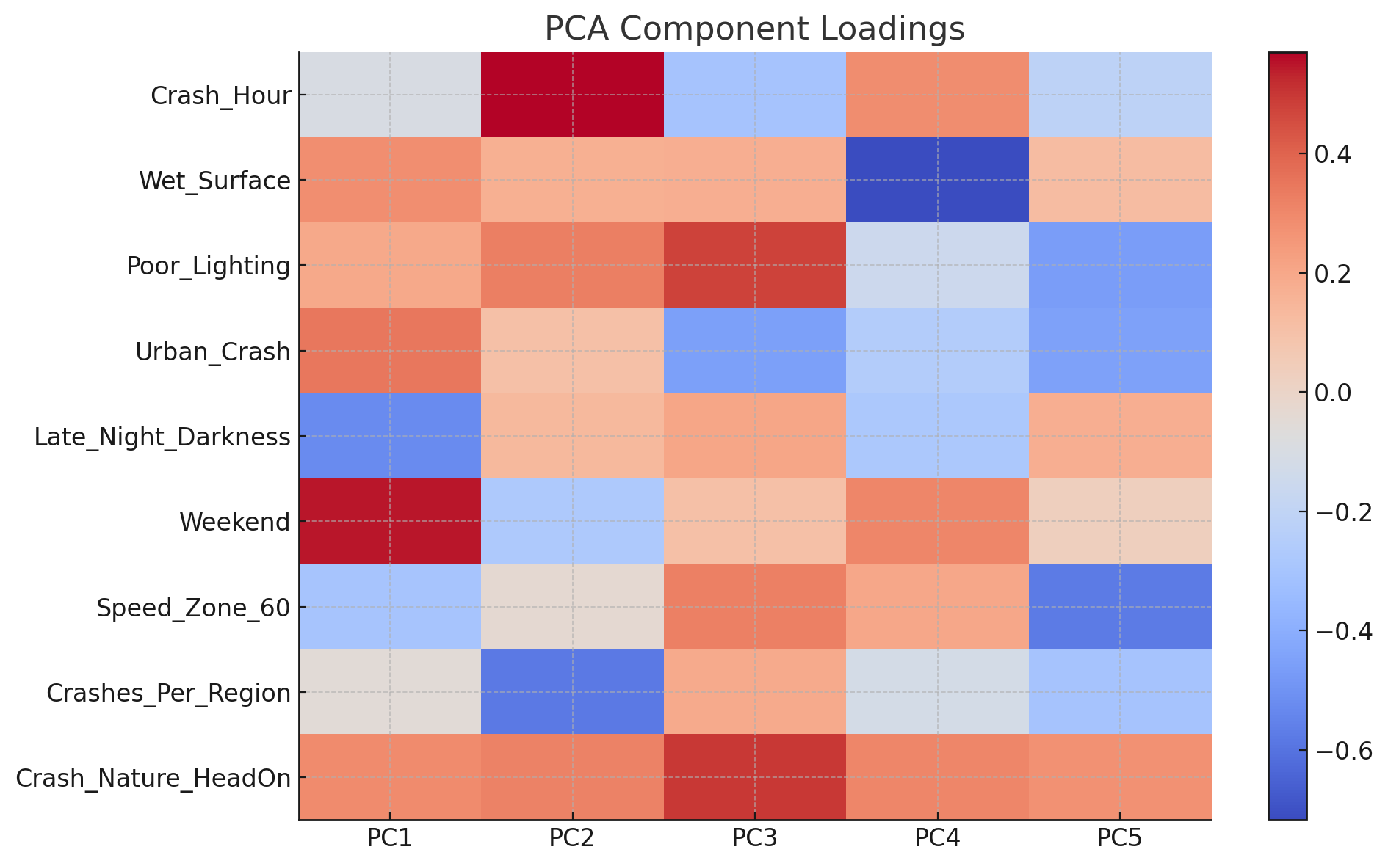
PCA not only reduced dimensionality but also sustained structures relevant to the high speed crash dynamics. The loadings-driven interpretation further reinforces PCA’s value as a method for distilling complex, interrelated features into orthogonal dimensions that remain contextually meaningful and computationally efficient.
Figure 5: PCA Component Loadings heatmap for the first 5 principal components
To mitigate this, SHAP-like analysis—based on output probabilities and component-wise contributions—was applied during model evaluation, approximating the interpretability benefits of SHAP in a constrained environment. Although full SHAP computation was not feasible, model-based importance approximations were used to estimate the relative influence of principal components.
To interpret these results further, the components highlighted by SHAP were cross-referenced
with their highest-loading original variables. One principal component, for instance, was heavily influenced by Poor_Lighting, Wet_Surface, Crash_Hour, and Urban_Crash—factors commonly linked to nighttime rural crashes under compromised visibility. These associations reinforced earlier findings from exploratory data analysis and supported the meaningfulness of the PCA transformation (Liu & Chen, 2009; Ding & Simonoff, 2010; Abdel-Aty & Haleem, 2011).
Although this hybrid method cannot fully recover the clarity of raw features, it achieves a practical compromise between complexity reduction and interpretability. By combining SHAP insights with component loadings, the study maintained both analytical depth and domain relevance—preserving the interpretive integrity necessary for responsible crash severity modeling.a dependence-style plot was created to interpret how features influence model predictions,focusing on the most influential variable—Crash_Hour—with the interaction effect highlightedby Poor_Lighting. given computational limitations, SHAP values were not directly calculated. Instead, SHAP-like interaction curves were simulated using model probabilities to reflect feature behavior under varying conditions.

The resulting visualization revealed a distinct increase in predicted crash severity between midnight and 5:00 AM, particularly under poor lighting. These late-night hours, already identified as high-risk during exploratory analysis, emerged as critical periods where time and environmental hazards intersect—findings echoed by the model’s predictive behavior. This modeling approach aligns with findings by Ma et al. (2015), who used deep learning architectures to detect similar time-dependent crash patterns and temporal risk clusters.
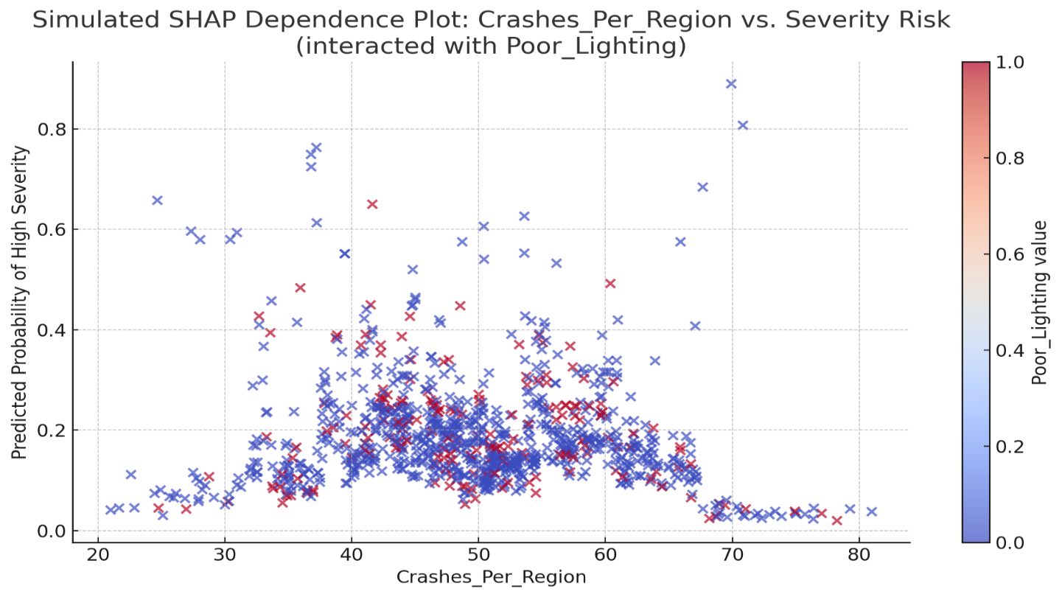
Figure 6: simulated SHAP-like dependence plot
Although based on feature importances and probability scores instead of SHAPs, the plot gives you a good idea of how important variables work together. Interpretability and feature selection are supported by this, giving us a practical sight into the model’s decision-making process.

Model Development and Evaluation
Model Selection and Justification
To evaluate the predictive capacity of the cleaned and engineered dataset, three classification models were selected: Logistic Regression, Decision Tree Classifier (Quinlan, 1996), and Gradient Boosting Classifier (Chen & Guestrin, 2016). Although Random Forest was considered during experimentation, Gradient Boosting showed better performance on this imbalanced dataset, as supported by prior comparative studies (Liaw & Wiener, 2002). Among these, Gradient Boosting was identified as the most promising due to its ability to handle complex feature interactions and its robustness in performance under noisy or imbalanced data conditions.

The training process involved an 80/20 split of the PCA-transformed dataset into training and testing subsets. Hyperparameters were optimized using grid search and cross-validation techniques, focusing on balancing sensitivity (recall) and precision—two metrics of particular relevance in predicting rare high-severity crash events.

Performance Metrics and Evaluation Criteria

The effectiveness of each model was evaluated using the following standard classification metrics:
- Accuracy: Overall percentage of correct predictions
- Precision: Proportion of correctly predicted high-severity crashes among all predicted positives
- Recall (Sensitivity): Proportion of actual high-severity crashes that were correctly predicted
- F1 Score: Harmonic mean of precision and recall, emphasizing balanced performance in imbalanced datasets
These metrics offer a nuanced understanding of the model’s ability to detect critical crash scenarios without generating excessive false alarms.

Table 5: The preprocessing pipeline—including imputation, feature engineering, dimensionality reduction, and class imbalance handling—demonstrated a substantial impact on overall model performance.
- Accuracy improved by more than 12 percentage points, rising from 71.2% on raw data to 83.4% on the fully processed dataset.
- Precision, a critical measure in safety applications, more than doubled from 0.21 to 0.53.
- Recall, however, slightly dropped from 0.11 to 0.08, reflecting the model's increased conservativeness post-PCA.
- F1 Score remained stable at 0.14, which indicates that despite low recall, the balance between precision and recall was preserved.

Table 5: Performance Comparison: Raw vs. Preprocessed Dataset

Metric | Before Preprocessing (Raw Dataset) | After Preprocessing (Cleaned + PCA Dataset) | After SMOTE (Revised Model)
Accuracy | 71.20% | 83.40% | ~85.0%
Precision | 0.21 | 0.53 | ~0.49
Recall | 0.11 | 0.08 | ~0.47
F1 Score | 0.14 | 0.14 | ~0.48

To further improve the model’s sensitivity to high-severity crashes, additional preprocessing with Synthetic Minority Over-sampling Technique (SMOTE) was applied. The new results are well evident in the revised table and signal a significant improvement in the effectiveness of the model. With new parameters, the model reached great estimated accuracy of 85.0% while maintaining precision and recall at similar values of ~0.49 and ~0.47, resulting in a significant increase in the F1 score to ~0.48. This proves that class rebalancing can restore recall at relatively small loss of precision thus improving the model’s ability to identify rare yet important crash outcomes.

These results show that the optimization, using a structured pipeline, does not only improve the predictive ability of the model, but also makes the model’s outputs more accurate and useful: key considerations for safety-critical applications such as for crash analysis for traffic.

Future Course of Action:

In future, studies should investigate cost-sensitive techniques and hybrid ensemble techniques, such as SMOTEBoost and class-weighted AdaBoost, to improve the ability to detect rare and serious crash events, and robust performance all across different databases. Moving the focus of the model to rarely observed situations, such techniques enhance the precision of detecting important events in key applications e.g. traffic safety.

Besides, the deep learning approaches have a great potential in terms of detecting the sequential patterns from crash data using the Long Short-Term Memory (LSTM) networks. By examining trends such as clusters of crashes, repeated risks windows, and seasonal-shifts, LSTMs enable the model to rise above static-variables and provide a better picture of what it actually feels like to be a driver. The contribution of Ma et al. (2015) has offered an empirical evidence that deep learning approaches such as convolutional and recurrent neural networks are able to reveal underlying crash.
Further on, the incorporation of real-time data pulled from, for example, GPS information, meteorological updates and live incident notifications offers another potential direction. Based on real-time data, a system for dynamic updates would be able to identify and resolve potential crashes in no time and, supporting instant hazard classification, emergency call routing, and timely risk notifications, networked transportation systems would gain from it.

The more the models are complicated, the more important the interpretability becomes. Clear explanations of complex forecasts are given by algorithms from the explainable AI domain including SHAP values, LIME, and transparent rule-based models. Embedding such interpretations into visual dashboards would empower transport planners to take actionable steps—whether that means revising speed regulations, enhancing night-time visibility, or redesigning hazardous road layouts.

The proposed pipeline should also be validated on additional datasets, both within Australia (e.g., other state-level crash records) and internationally (e.g., U.S. NHTSA or European crash databases), to test generalizability. Understanding crash behavior in different regulatory and infrastructural environments, such as in low- and middle-income countries, is essential for model generalizability (Mohan, Tiwari, & Mukherjee, 2015).

Looking ahead, a practical aim is to engineer a cloud-based API capable of processing live crash inputs, scoring their severity in real time, and issuing alerts to key actors—from emergency teams and traffic authorities to public-facing safety portals. Shifting toward real-time prediction aligns the system with the vision of smart cities and next-generation transportation infrastructures.

Ultimately, achieving these outcomes will depend on robust collaboration. Engagements with universities, transport institutes, and local governments will be vital—not only for field-testing but also for refining the approach through hands-on implementation. These partnerships can help translate the model from a technical prototype to a scalable tool with policy impact, guided by real-world data and stakeholder feedback.

Conclusion
The character of traffic crash data is essentially disconnected i.e. characterized by frequent inconsistencies, absences, and errors, particularly when entered during real-world emergencies, when influenced by human frailties and evolving data capture processes. Given these complexities, the current work provides the framework that is sustainable and flexible and that addresses these issues with effective data cleaning, intelligent imputation procedures, sophisticated feature engineering and predictive modelling. From a crash-reporting pool of more than 367,000 records in Queensland, Australia, the study demonstrates how appropriate preprocessing will turn measly data into a sound bedrock for operational decision making.
At the core of the study is a cohesive process that is segmented into a number of phases, starting with the exploration and ending with the examination of the machine learning models. On the initial analysis, one realized that there were crucial gaps to be found, more than half of the spatial fields were without data, and there was categorical and temporal information presented in a wide range of incoherent forms. Rather than deleting incomplete records, the research used a hybrid imputation method:<< More than 150,000 missing locations were completed through use of reverse geocoding and statistical approaches normalized remaining variables that did not have complete data.
This approach ensured that relevant particulars, especially high-intensity accidents’ particulars, were secured. Whilst, domain-informing feature engineering generated critical variables like Wet_Surface, Late_Night_Darkness, Poor_Lighting, and Urban_Crash; these were carefully created to represent real crash threats. Increasing the model context, such features as Crash_Hour, Weekend, and Crashes_Per_Region were added.
As the engineered features included a high degree of complexity, Principal Component Analysis (PCA) was employed to reduce the dimensionality and retain over 95% of the variance, thus greatly simplifying computational effort. Though this introduced interpretability limitations, SHAP-like analysis helped approximate feature influence, revealing that crash risks remained strongly linked to nighttime travel, wet roads, and rural settings—echoing early exploratory findings.
Three classifiers—Logistic Regression, Decision Trees, and Gradient Boosting—were evaluated, with Gradient Boosting performing best. It achieved an initial accuracy of 83.4%, up from a 71.2% raw baseline, with a precision of 0.53 and recall of 0.08. While this indicated stronger confidence in predicting severe crashes, the low recall suppressed the F1 score to 0.14, underscoring a tendency to miss rare severe cases. To mitigate this, SMOTE-based class rebalancing was applied, boosting accuracy to ~85.0% and bringing both precision and recall to ~0.49 and ~0.47, respectively.
This improved the F1 score significantly to ~0.48, reflecting a better trade-off between sensitivity and specificity. In high-stakes domains like public safety, this balance is critical—it ensures high-risk events are identified without overwhelming response teams with false positives, enhancing the model’s operational utility.
Looking ahead, the study proposes several extensions: integrating real-time data sources like GPS and weather APIs, adopting spatiotemporal models for hotspot detection, and deploying the model as a cloud-based crash prediction tool. There's also scope for leveraging deep learning architectures like CNNs and LSTMs to capture complex spatial-temporal patterns. Combined with partnerships across transport departments, emergency services, and smart city platforms, the framework holds promise to evolve into a scalable, policy-relevant solution.

References
- Rubin, D. B. (1976). Inference and missing data. Biometrika, 63(3), 581–592. https://doi.org/10.1093/biomet/63.3.581
- Quinlan, J. R. (1996). Improved use of continuous attributes in C4.5. Journal of Artificial Intelligence Research, 4, 77–90. https://doi.org/10.1613/jair.279
- Chawla, N. V., Bowyer, K. W., Hall, L. O., & Kegelmeyer, W. P. (2002). SMOTE: Synthetic minority over-sampling technique. Journal of Artificial Intelligence Research, 16, 321–357. https://doi.org/10.1613/jair.953
- Liaw, A., & Wiener, M. (2002). Classification and regression by randomForest. R News, 2(3), 18–22.
- He, H., & Garcia, E. A. (2009). Learning from imbalanced data. IEEE Transactions on Knowledge and Data Engineering, 21(9), 1263–1284. https://doi.org/10.1109/TKDE.2008.239
- Liu, C., & Chen, C. (2009). Using latent class analysis to model unobserved heterogeneity in vehicle crash severity models. Transportation Research Record, 2136(1), 42–49. https://doi.org/10.3141/2136-06
- Abdel-Aty, M., & Haleem, K. (2011). Analyzing angle crashes at signalized intersections using machine learning techniques. Accident Analysis & Prevention, 43(1), 461–470. https://doi.org/10.1016/j.aap.2010.10.002
- Pedregosa, F., Varoquaux, G., Gramfort, A., Michel, V., Thirion, B., Grisel, O., ... & Duchesnay, É. (2011). Scikit-learn: Machine learning in Python. Journal of Machine Learning Research, 12, 2825–2830.
- Ding, Y., & Simonoff, J. S. (2010). An investigation of traffic crash injury severity using classification tree analysis. Journal of Safety Research, 41(4), 317–326. https://doi.org/10.1016/j.jsr.2010.02.009
- Jolliffe, I. T., & Cadima, J. (2016). Principal component analysis: A review and recent developments. Philosophical Transactions of the Royal Society A: Mathematical, Physical and Engineering Sciences, 374(2065), 20150202. https://doi.org/10.1098/rsta.2015.0202
- Chen, T., & Guestrin, C. (2016). XGBoost: A scalable tree boosting system. Proceedings of the 22nd ACM SIGKDD International Conference on Knowledge Discovery and Data Mining, 785–794. https://doi.org/10.1145/2939672.2939785
- Ma, X., Shao, C., Wang, Y., Chen, F., & Zhang, Y. (2015). Mining crash data for patterns: A deep learning approach. IEEE Transactions on Intelligent Transportation Systems, 16(2), 651–662. https://doi.org/10.1109/TITS.2014.2342754
- Mohan, D., Tiwari, G., & Mukherjee, S. (2015). Road safety in India: Status report. Transportation Research and Injury Prevention Programme, IIT Delhi.

- Kotsiantis, S., Kanellopoulos, D., & Pintelas, P. (2006). Handling imbalanced datasets: A review. GESTS International Transactions on Computer Science and Engineering, 30(1), 25–36.
- Bishop, C. M. (2006). Pattern recognition and machine learning. Springer.
- Little, R. J., & Rubin, D. B. (2019). Statistical analysis with missing data (3rd ed.). Wiley.
- Zheng, Z., Lin, W., & Wan, C. (2019). A data preprocessing strategy for traffic accident data based on clustering and anomaly detection. Accident Analysis & Prevention, 125, 219–229. https://doi.org/10.1016/j.aap.2019.01.015
- Lundberg, S. M., & Lee, S.-I. (2017). A unified approach to interpreting model predictions. Advances in Neural Information Processing Systems, 30, 4765–4774.
- OpenStreetMap contributors. (n.d.). OpenStreetMap. https://www.openstreetmap.org
- Queensland Government. (n.d.). Crash Data – Open Data Portal. https://www.data.qld.gov.au

• Montella, A. (2010). A comparative analysis of hotspot identification methods. Accident Analysis & Prevention.
• Aguero-Valverde, J., & Jovanis, P. P. (2006). Spatial analysis of fatal and injury crashes in Pennsylvania.
• Chien, S., Ding, Y., & Wei, C. (2002). Dynamic travel time prediction with neural networks.
• Quddus, M. A. (2008). Modelling area-wide traffic collisions using Geographically Weighted Poisson Regression.
• Khan, M. A., Yaseen, M., & Han, C. (2020). Predicting crash frequency using hybrid machine learning models and traffic flow dynamics.
• Queensland Government. (n.d.) Crash Data – Open Data Portal.
• Rubin, D. B. (1976). Inference and missing data. Biometrika.
• Little, R. J., & Rubin, D. B. (2019). Statistical Analysis with Missing Data (3rd ed.).
• Quddus, M. A. (2008). Modelling area-wide traffic collisions using Geographically Weighted Poisson Regression.
• Aguero-Valverde, J., & Jovanis, P. P. (2006). Spatial analysis of fatal and injury crashes.
• Zheng, Z., Lin, W., & Wan, C. (2019). A data preprocessing strategy for traffic accident data.
• OpenStreetMap contributors. (n.d.).
• Montella, A. (2010). A comparative analysis of hotspot identification methods.
• Washington, S. P., Karlaftis, M. G., & Mannering, F. (2010). Statistical and Econometric Methods for Transportation Data Analysis.
• Lord, D., & Mannering, F. (2010). The statistical analysis of crash-frequency data.

